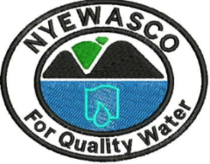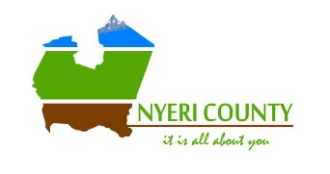
PUBLIC NOTICE
INVITATION FOR APPLICATIONS FOR VACANT POSITIONS IN THE BOARD OF DIRECTORS OF NYERI WATER AND SANITATION COMPANY LIMITED

Nyeri Water and Sanitation Company (NYEWASCO) is a Limited Liability Company fully owned by the County Government of Nyeri and is one of the Water Service Providers in Nyeri County responsible for efficient and economical provision of water and sanitation services in Nyeri Town Sub County and its environs.

The Company seeks to fill the vacant positions for the Board of Directors. The Board of Directors comprises of the representatives of stakeholders identified by the Company and the County Government of Nyeri in accordance to the Water Sector Corporate Governance Guidelines issued by the Water Services Regulatory Board.

The Board has vacancies for representatives of the following stakeholders
- One (1) Director representing the Professional Institutions
- One (1) Director representing the Residents Associations

ELIGIBILITY
To be eligible for appointment, one MUST meet the following criteria: -
- Minimum Bachelor’s degree forma recognized university
- Minimum seven (7) years working experience in the core profession or have run own enterprise for a minimum of (7) years
- Must be nominated by a stakeholder group registered with NYEWASCO
- Must meet leadership and integrity criteria under Chapter 6 pf the constitution of Kenya and meet Fit & Proper Test criteria from WASREB (attach the following documents): -
- Certificate of Good Conduct (DCI)
- Clearance Certificate from Credit Reference Bureau (CRB)
- Clearance Certificate from Higher Education Loans Board (HELB)
- Tax Compliance Certificate (KRA)
- Clearance Certificate from Ethics and Anti-Corruption Commission (EACC)
- Duly Filled Fit & proper Test Form witnessed by a commissioner of oaths or magistrate (form is available on NYEWASCO website www.nyewasco.co.ke)

NOTE
- Suppliers and other trading associates of the Company are not eligible for directorship positions at the Company
- Persons in current professional and social relationships with directors of the Company cannot become directors of the Company.

APPLICATION INSTRUCTIONS
All application packages in sealed envelopes clearly marked “APPLICATION FOR DIRECTORSHIP IN NYEWASCO” which include cover letter, duly filled Fit & Proper Test Form, CV and Certified Copies of Certificates and testimonials should be sent by post or courier to: -

The Chairperson, Selection Committee
Nyeri Water and Sanitation Company Limited
Off Kenyatta Road opp. Nyeri health Center
P.O Box 1520-10100
Nyeri, Kenya

CLOSING DATE: 19TH MAY 2021, 11.00 a.m.

