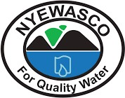
NYERI WATER AND SANITATION COMPANY LIMITED

WATSAN FOCUS
A Publication by Nyeri Water and Sanitation Co. Ltd Quarter 4 2023/ 2024 Issue

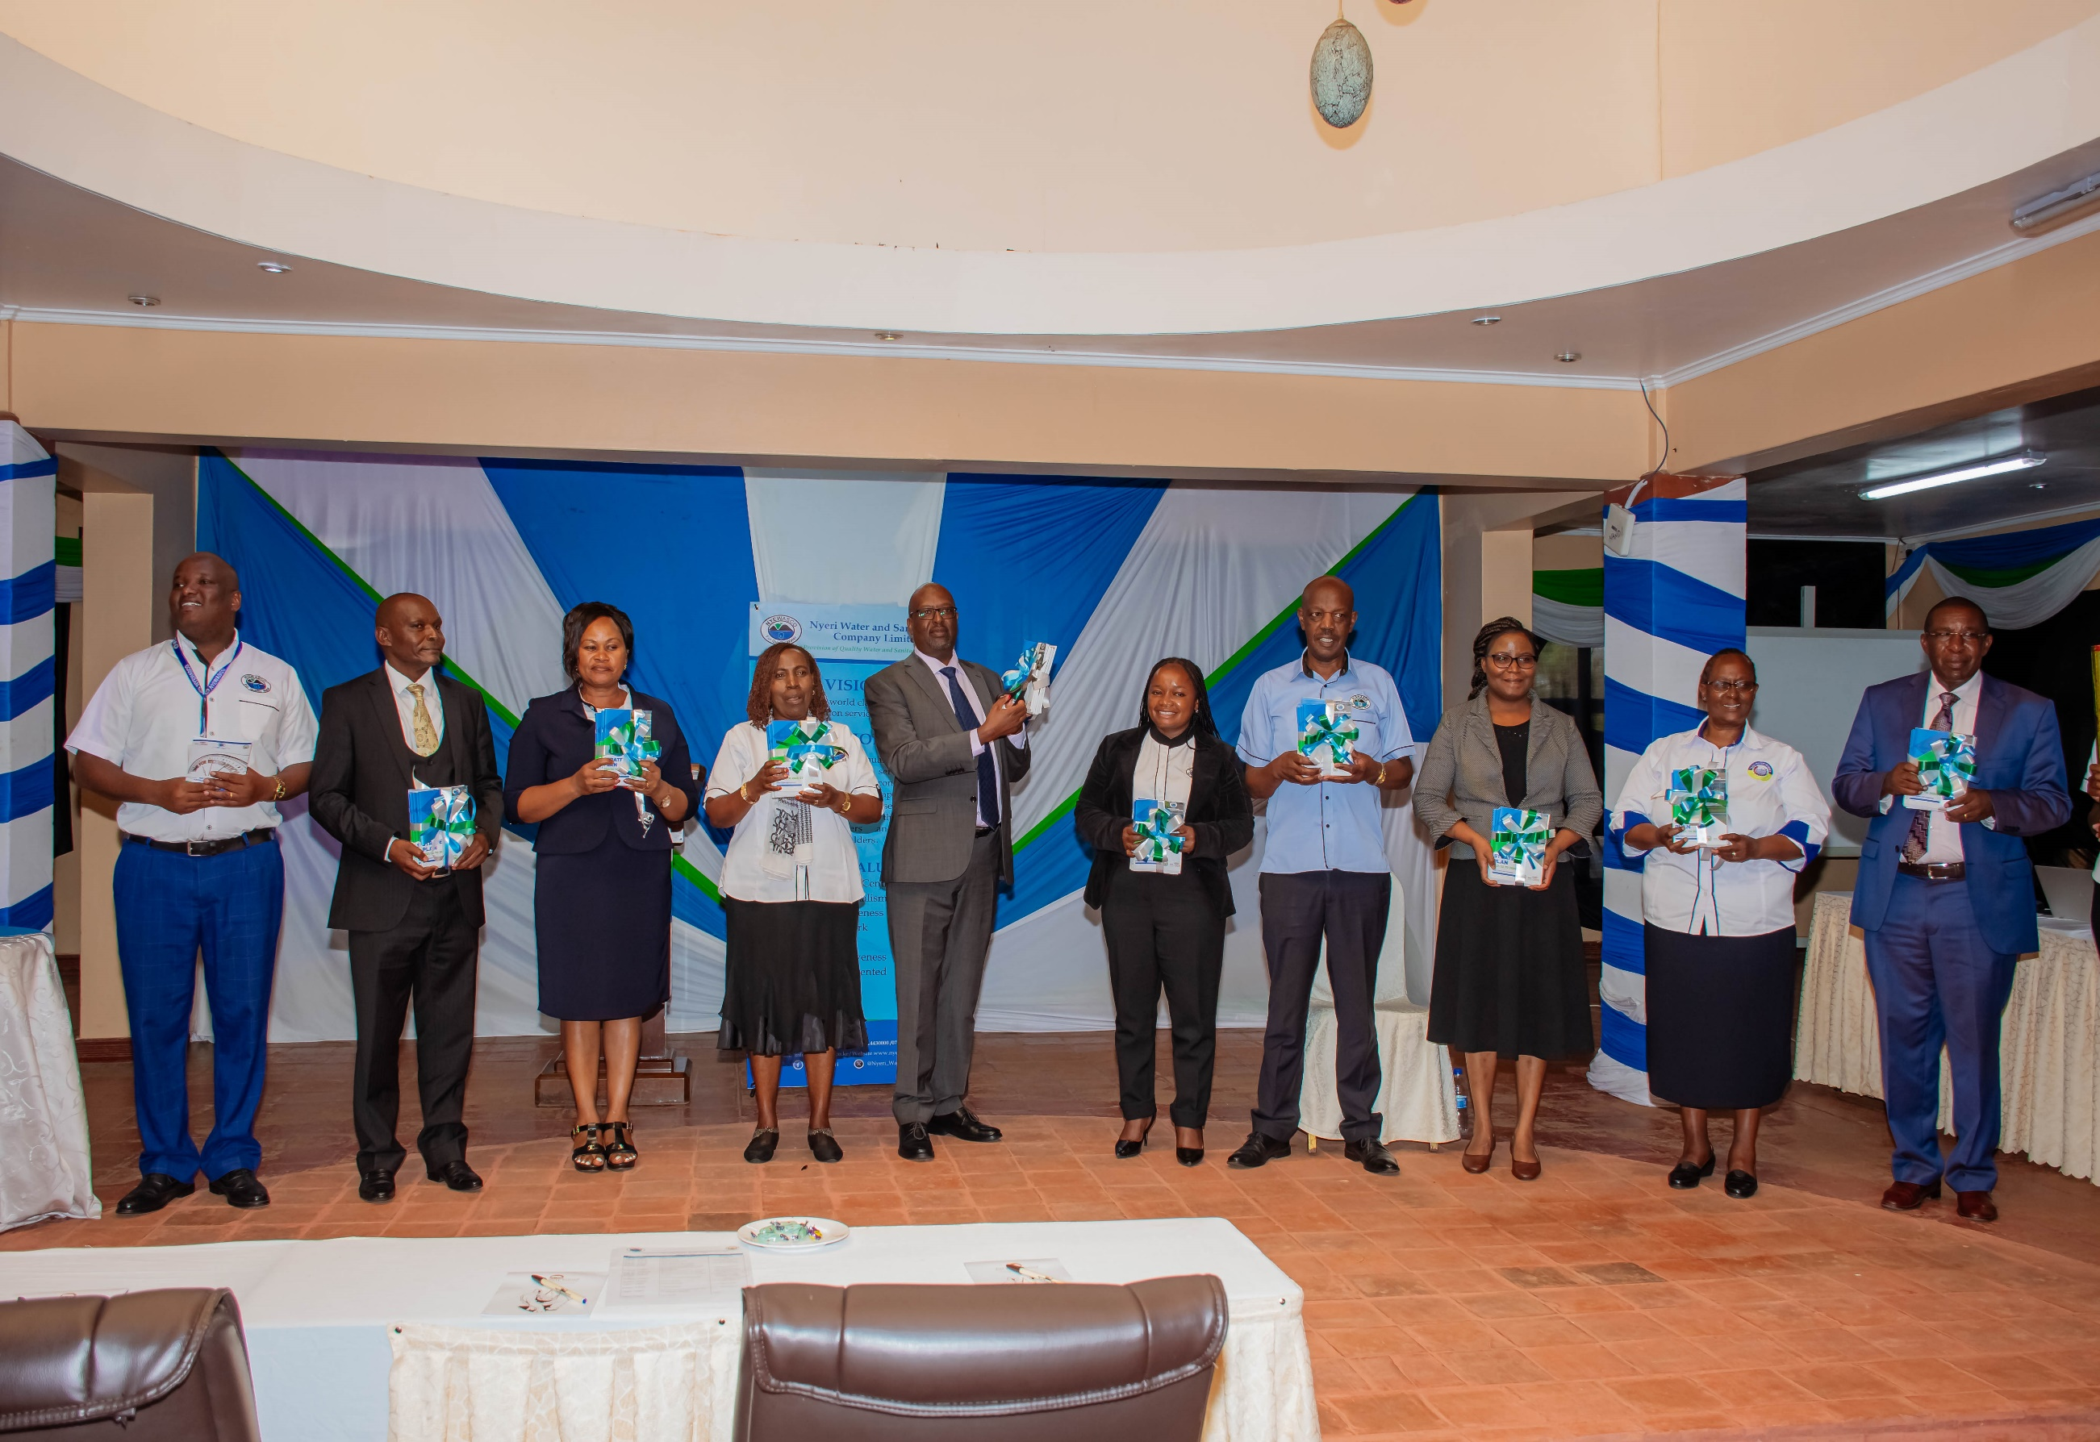




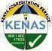

ISO 9001:2015
ISO/IEC @waternyeri @Nyeri_water @NYEWASCO 17025:2017
Certified
Accredited

Nyeri Water and Sanitation Company Limited (NYEWASCO) off Kenyatta Road, Behind Nyeri County Fire Offices,
P.O. Box 1520-10100 Nyeri, Kenya. Toll Free Number: 0800721095, Cell Phone: 0714430000/0722461359/0734732481,
Email: info@nyewasco.co.ke, Website: www.nyewasco.co.ke.

TABLE OF CONTENTS
4th QUARTER 2023/24 GENERAL STAFF MEETING………………………………………………….3
EARTH DAY- 22ND APRIL,2024…………………………………………………………………………4
TREE GROWING DAY AT OLD CHANIA PUMPING STATION AND OLD MWEIGA WATER WORKS……………………………………………………………………………………………5
CARRY A GIRL FOR A TERM CAMPAIGN………………...…………………………………………6
THE MATER HEART RUN 2024 EDITION…………………………………………………………….7
corporate sports day……………………………………………………………………………...8
STAKEHOLDERS’ CONFERENCE………………………………………………………………………9
LAUNCH OF THE REVIEWED STRATEGIC PLAN FY (2021/22-2026/27)………………….…….10
WORLD ENVIRONMENT DAY………………………………..………………...…………………….12
RELEASE OF IMPACT REPORT NO. 16 BY WASREB…………………………………...…………13
SPECIAL GENERAL CORPORATE MEETING………………………………………………………14
3RD COHORT INTERNS GRADUATION……………………………………………………………15
UPSCALING BASIC SANITATION FOR THE URBAN POOR (UBSUP) PHASE II………...…16
CORPORATE SOCIAL RESPONSIBILITY INITIATIVES ‘IN THE HEART OF CSR’…………..17
NYEWASCO SACCO UPDATES………………………………………………………………………..18
NYEWASCO WELFARE UPDATES……………………………………………………………………..19
WASCO GAMES………………………………………………………………………………...…………20
MAY & JUNE BIRTHDAY CELEBRANTS……………………………………………….…………….21
NYEWASCO IN PICTURES……………………………………………………………………………...22
TUMULIKE MWIZI PAMOJA CAMPAIGN…………………………………………………………..24
OUR SERVICES…………………………………………………………………………………………....25
NYEWASCO ANTHEM………………………….…………………………………..…………………..26

4th QUARTER 2023/24 GENERAL STAFF MEETING.
Nyewasco convened its 4th quarter general staff meeting on the 9th of April 2024, marking another significant gathering for reflection and planning. The meeting began with a spiritual touch, featuring a sermon inspired by Exodus 7:8-16, which emphasizes the power of faith and perseverance. The message, resonating with the theme of overcoming challenges, was well-received by the staff.

Following the sermon, the meeting transitioned to a series of updates from the Chief Managers and Managers. They shared insights into the company’s progress over the past quarter, highlighting achievements and areas for improvement. The updates also covered the latest developments in the Union, Welfare, Sacco activities, and the WASCO Games, providing a comprehensive overview of the company’s multifaceted engagement with its employees.

The Managing Director, in his keynote address, expressed a forward looking stance, filled with optimism for the year ahead. He shared goodwill messages from the chairperson and the Board of Directors, acknowledging the collective efforts of the staff.

The meeting's closing segment was the introduction of a consultant from PGH, who provided an informative discussion on mental health awareness. This discussion emphasised the significance of mental well-being in the workplace and provided helpful insights into how to preserve psychological health while navigating professional responsibilities.
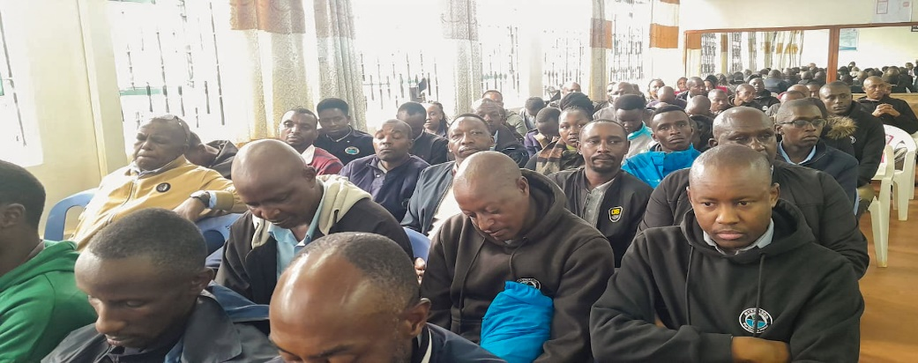
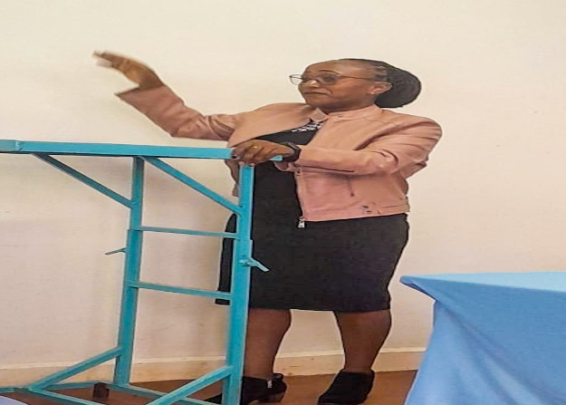
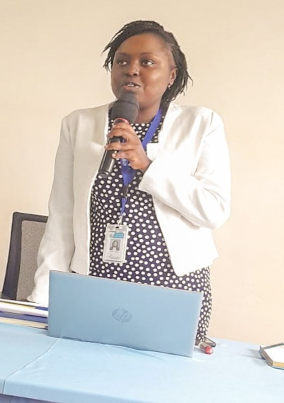
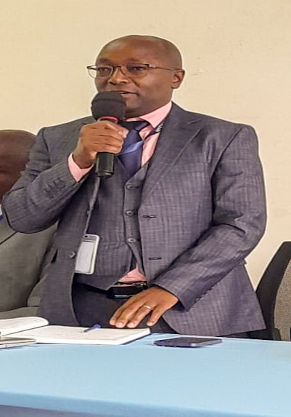
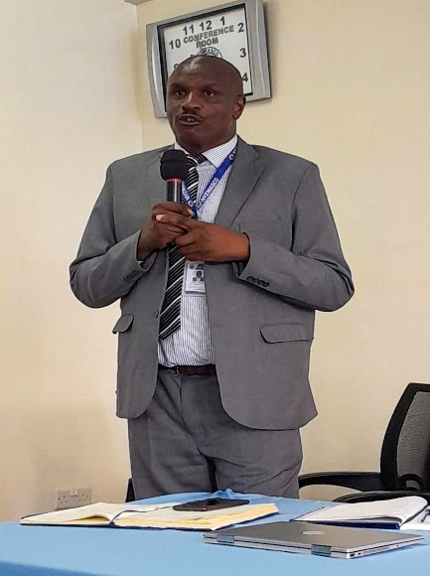
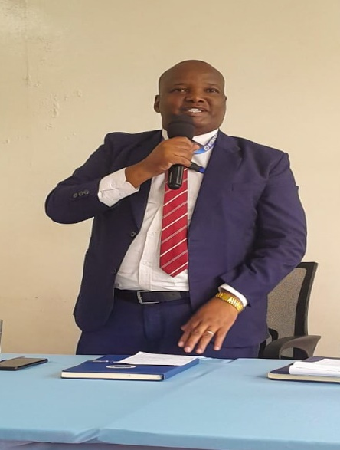
The preacher of the day Ann Maina giving the sermon of the day.
Nyewasco staff members during the general staff meeting.
Above: The Managing Director, Chief Manager Technical Services, Chief Manager Commercial Services and Chief Manager Finance and Corporate Services giving the directorates updates respectively.

EARTH DAY- 22ND APRIL, 2024

Earth Day is an international day celebrated on 22 April and is devoted to our planet. It draws attention to the environment and promotes conservation and sustainability. It is celebrated to create awareness among people to solve various problems like climate change and pollution, activate various environment movements and awareness programs, conserve natural resources, protect endangered species, and move towards a sustainable future.

This year’s theme, Planet vs. Plastics, emphasizes the urgent need to address the overwhelming presence of plastics in our environment and its detrimental effects on human and planetary health.

The theme for Earth Day 2024 was announced by EARTHDAY.ORG with a clear and ambitious goal: to demand a 60% reduction in the production of plastics by 2040 and to pave the way for a plastic-free future. The campaign unites individuals, communities, businesses, and governments in a collective effort to reduce our reliance on plastics and to mitigate their harmful impact.

In line with this year’s theme and the spirit of Earth Day, NYEWASCO and the Young Water Professionals organized a tree planting event at Kangemi Sewer Treatment Plant. This initiative was a practical step towards environmental conservation, where over 500 trees were planted on that day, contributing to the greening of the planet and the promotion of sustainable practices. Such actions are vital in the fight against climate change and in fostering a healthier ecosystem for all.

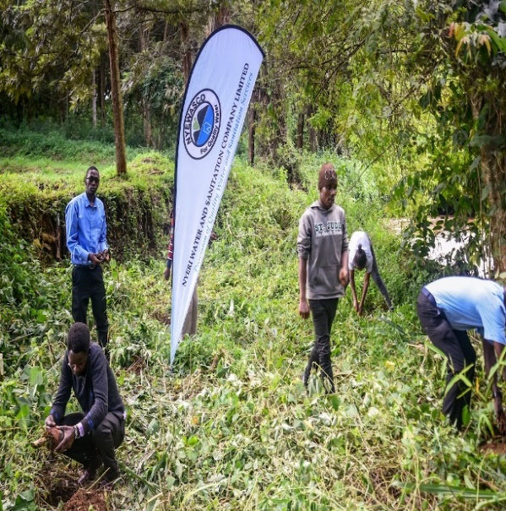
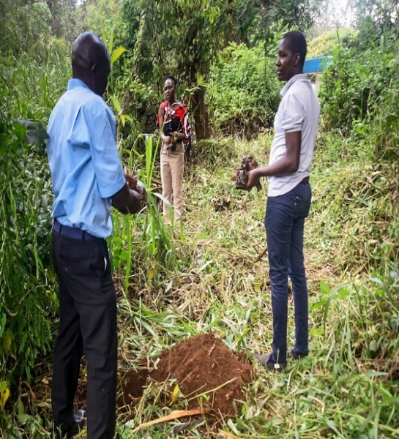
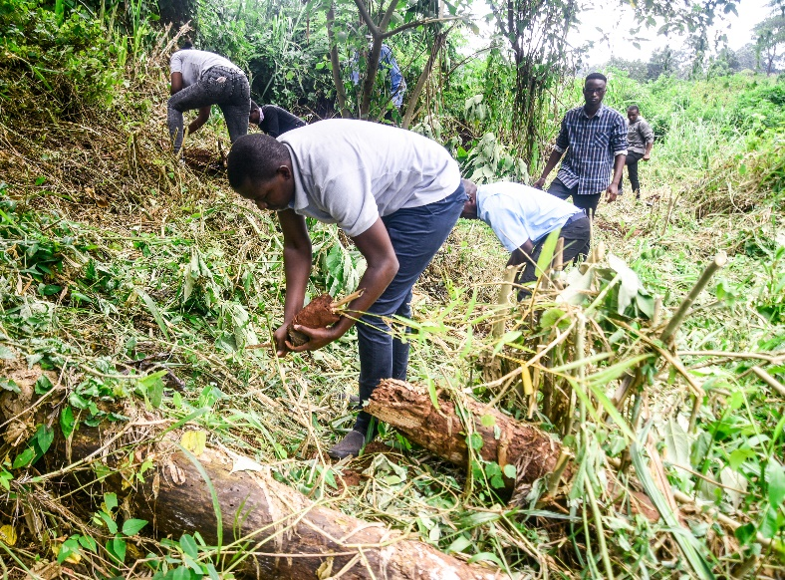

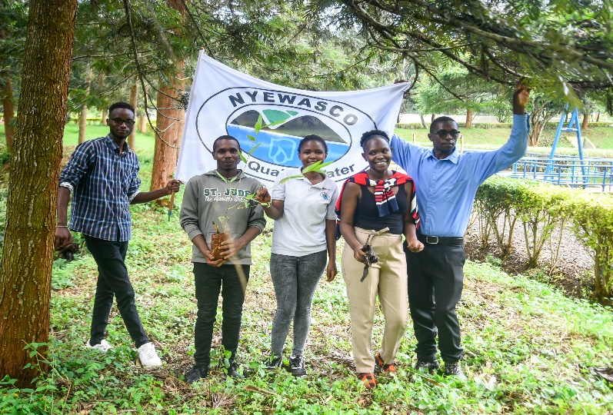
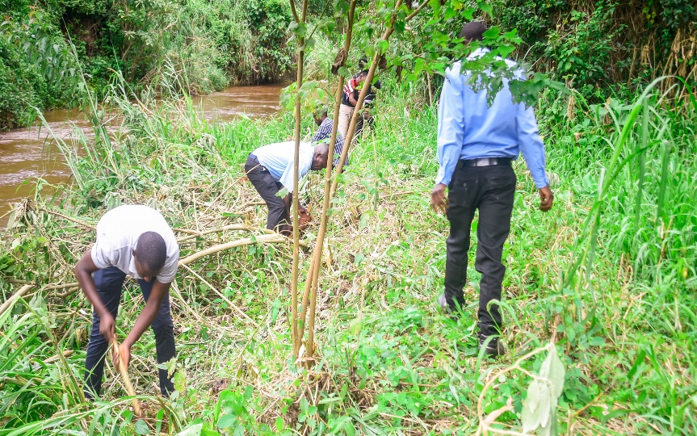
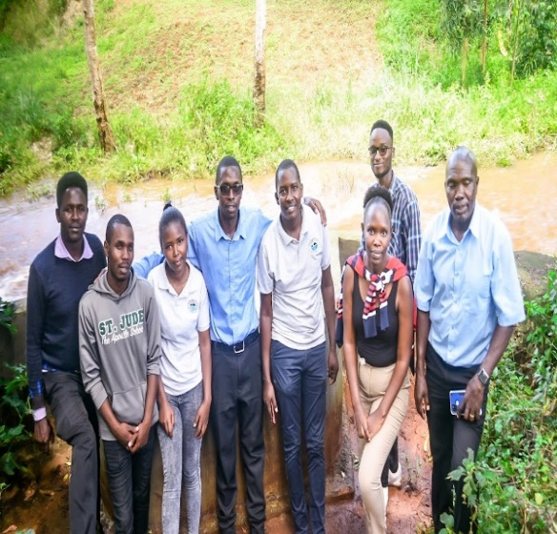

Above: Pictures of participants during the tree planting session at Kangemi Sewer Treatment Works.

TREE GROWING DAY AT OLD CHANIA PUMPING STATION AND OLD MWEIGA WATER WORKS.
Nyewasco took a big step towards their goal of planting one million trees by organizing a tree-growing exercise at the Old Chania Pumping Station and Old Mweiga Water Works on May 8th, 2024. Led by Managing Director Eng. Peter Kahuthu, the event saw the planting of over 5000 tree seedlings. Alongside Eng. Kahuthu were Chief Manager Technical Services Eng. James Ngunjiri and Chief Manager Commercial Services CPA Francis Kiura, along with dedicated staff members. The presence of representatives from the County's Department of Water, Irrigation, Environment, and Climate Change, as well as the Kenya Institute of Management, highlighted the collaborative effort towards environmental conservation.

This initiative is part of Nyewasco's strategic plan to contribute to national efforts aimed at achieving a 10 percent tree cover, as directed by the President. By planting trees at key locations like the pumping station and water works, Nyewasco aims to enhance environmental sustainability and promote a greener future for generations to come. The enthusiastic participation of staff underscores Nyewasco's commitment to environmental stewardship and community engagement, setting a positive example for others to follow. Through such endeavors, Nyewasco continues to demonstrate its dedication to serving not just the community's water needs but also its broader responsibility towards the environment.
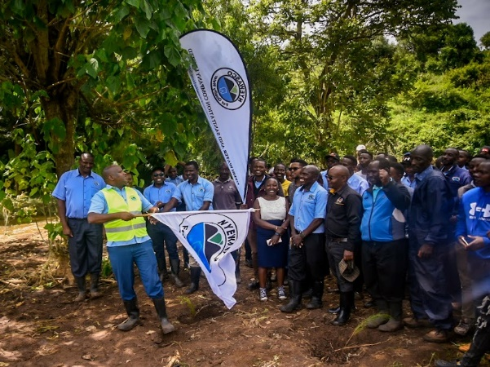

Top Left: The MD flagging of the event

Bottom Left: A group photo of all participants in attendance

Top Right: Members of staff planting their seedlings.

Middle Right: The MD and Representatives from the County Government of Nyeri plant a tree.

Bottom Right: A group photo of representatives from Kenya Institute of Management.

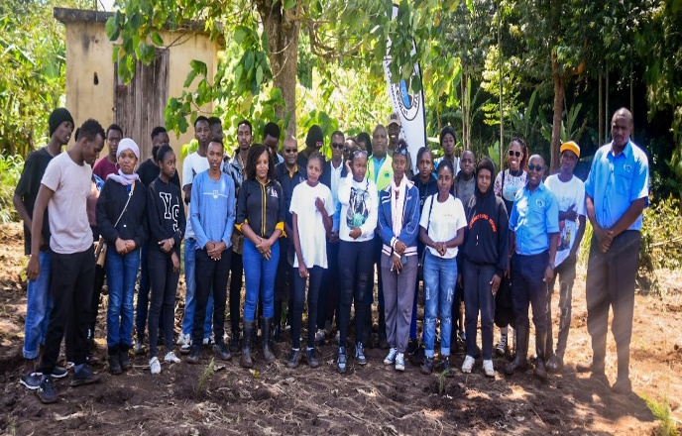

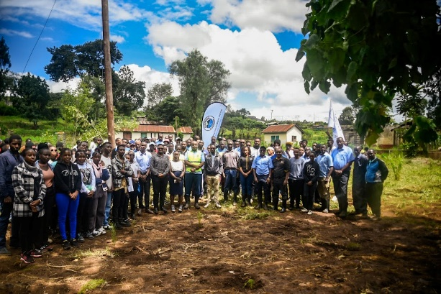

CARRY A GIRL FOR A TERM CAMPAIGN
‘Menstrual Hygiene Day’

On May 24, 2024, NYEWASCO, in partnership with Women in Water and Sanitation (WIWAS), marked Menstrual Hygiene Day with an impactful event at the Nyewasco conference hall. The initiative aimed to provide sanitary products to pupils of St. Luke’s Githwariga Primary School and Nyakinyua Primary School.

Held under the theme “Carry a girl for a term,” the event saw collaboration from Nyewasco, Tana Water Works, WIWAS, and Murang’a Water and Sanitation Company, with key stakeholders in attendance. Keziah Nyambura, Nyewasco’s Manager Legal Services, served as the Master of Ceremonies, while the main speaker from WIWAS emphasized the importance of menstrual hygiene management for young girls’ education and well-being.

The event featured entertainment by pupils, who performed poems to raise awareness about menstrual health. Each student received a dignity pack containing essential sanitary products, ensuring they could manage their menstrual health with dignity and comfort. This initiative symbolized a step towards eliminating barriers that hinder girls’ education due to lack of access to sanitary products. The success of the event highlighted the significant impact that community collaboration can achieve for a noble cause.

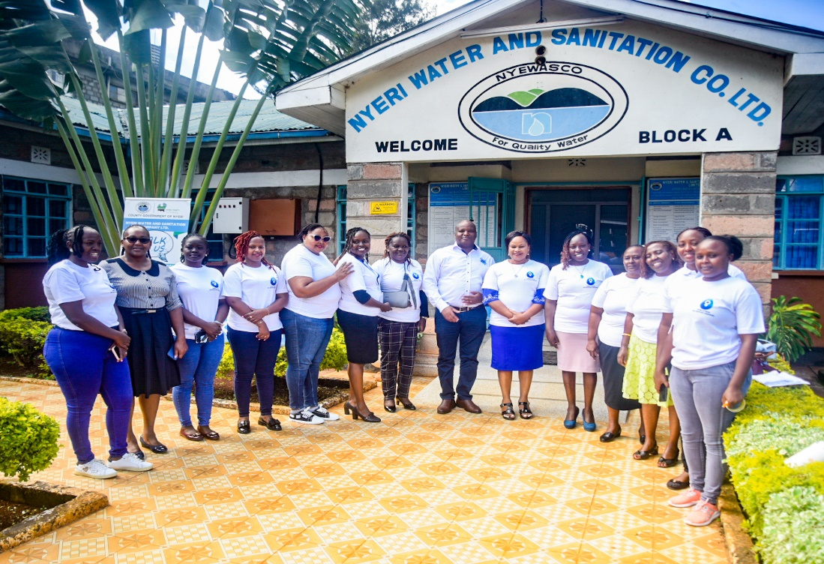
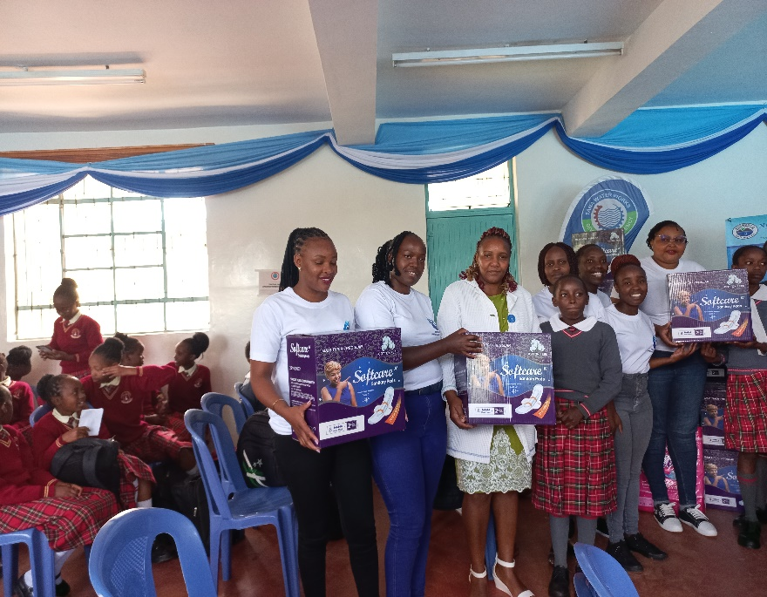

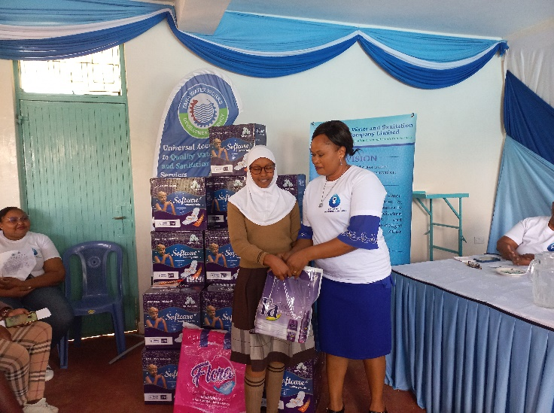
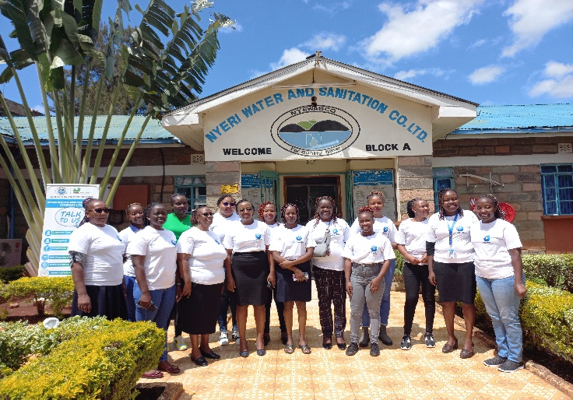
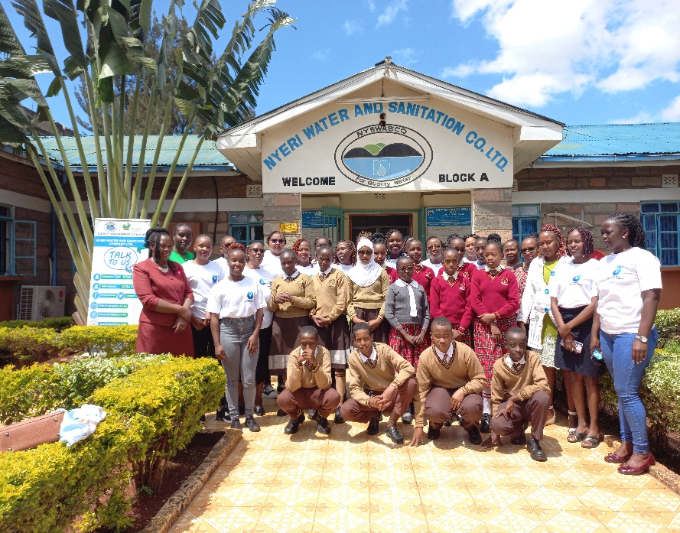
THE MATER HEART RUN 2024 EDITION
Above: Photos from the WIWAS event held at Nyewasco conference hall to mark Menstrual Hygiene Day.
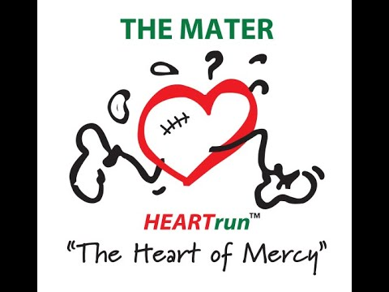
The Mater Heart Run, which began in 2002, is an annual fundraising event for the Cardiac program. The run aims to raise awareness and donations to support children with heart conditions, particularly those from disadvantaged backgrounds who require cardiac surgery or treatment. During a breakfast launch at the Mater Hospital in Nairobi, Sr. Dr. Mary Ngui, the facility’s CEO, highlighted the program’s impact. Since its inception, the Mater Heart Run has benefited 5,448 children. Among them, 2,242 underwent heart surgeries, while 3,206 received cardiac catheterization and intervention procedures. Additionally, the program conducts awareness campaigns for rheumatic fever and provides training for staff caring for cardiac patients. The program continues to make significant strides in improving the lives of children with heart conditions, thanks to the support of well-wishers and dedicated organizations.

This year’s run was held on Saturday 25th May 2024 at the Dedan Kimathi University grounds. NYEWASCO actively participated in the Mater Heart Run, demonstrating its commitment to corporate social responsibility (CSR). By sponsoring a team drawn from staff members, the company played a crucial role in uplifting community well-being and contributing to better healthcare services. The involvement demonstrates dedication to making a positive impact on society and saving countless lives through initiatives like the Mater Heart Run.
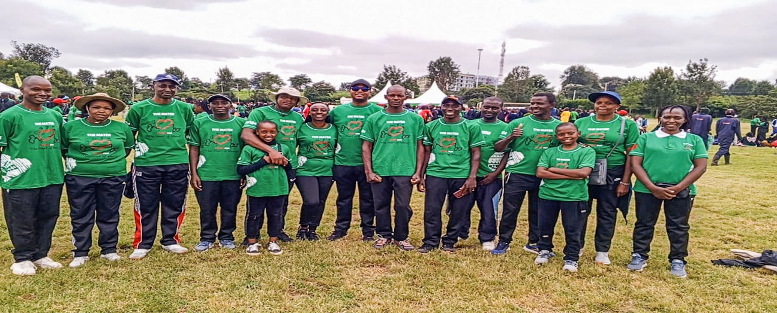

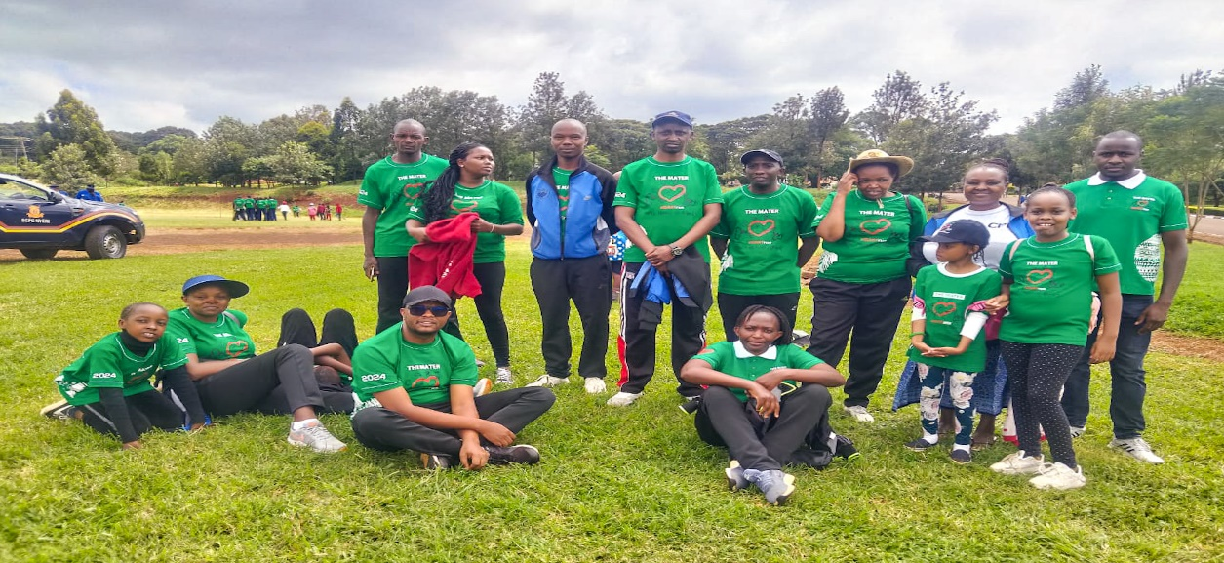
The team that represented NYEWASCO at the Mater Heart Run, 2024 Nyeri Edition.

CORPORATE SPORTS DAY
Official Launch of the 13th Edition Wasco Games
As the 13th Edition of the WASCO Games approaches, NYEWASCO has been diligently preparing to showcase its athletic prowess and team spirit. The company’s preparations kicked off with a Corporate Sports Day held on May 31, 2024, at the old Ruring’u Stadium, which also served as the official launch for the games. This event was instrumental in forming diverse teams, ensuring that NYEWASCO will have a strong presence in track events, field events, and throws.
In the lead-up to the games, scheduled for August 12th to 16th, 2024, NYEWASCO has committed to a structured training program to hone the skills of its athletes. Team captains, along with the team manager and deputy, are closely monitoring the progress to ensure peak performance. The emphasis on regular exercise and fitness contributes significantly to the overall well-being of the staff, aligning with the company’s health initiatives.
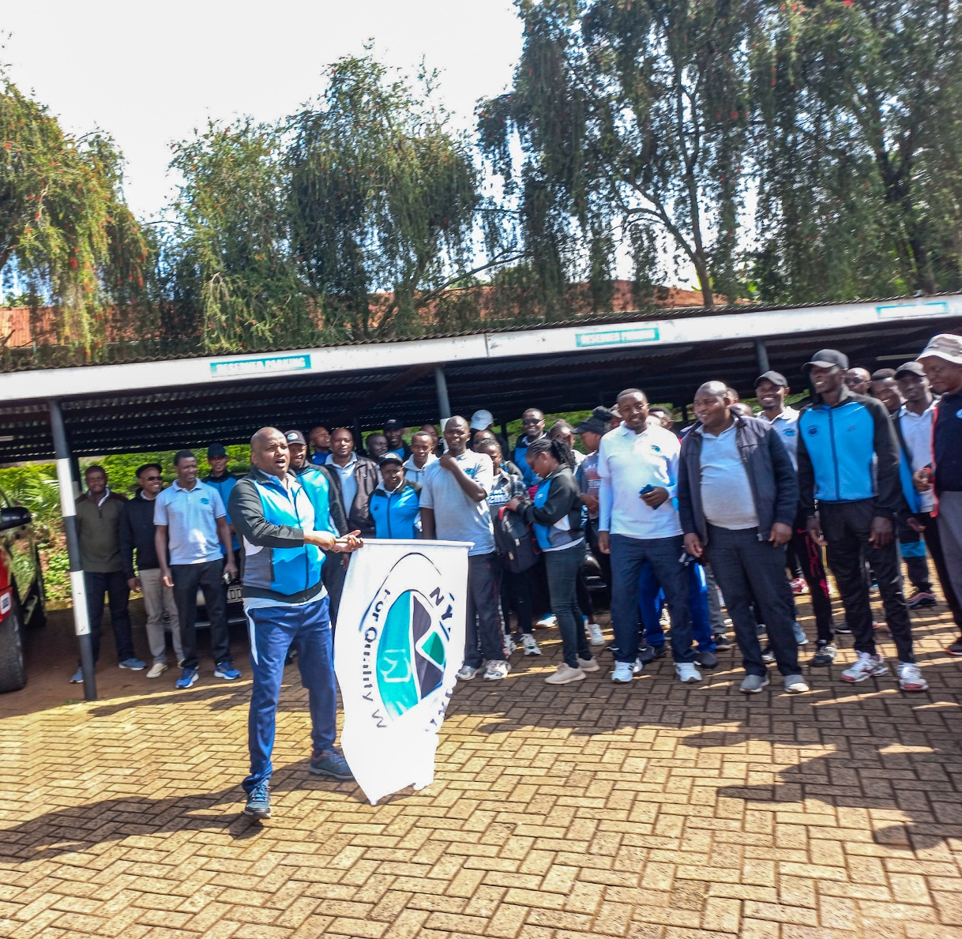

Beyond physical preparation, the WASCO Games are a platform for networking, learning, and sharing best practices among water service providers. NYEWASCO values this opportunity for its staff to engage with peers from other companies, fostering a culture of continuous improvement in service delivery. The company’s active participation in the WASCO Games underscores its commitment to community, teamwork, and excellence both on and off the field.





STAKEHOLDERS’ CONFERENCE

NYEWASCO continued its tradition of fostering dialogue and collaboration at its annual stakeholders' conference, held on June 3rd at the White Rhino Hotel. Representatives from diverse sectors, including government agencies, community organizations, environmentalists, and industry experts, gathered for a day dedicated to advancing the provision of quality water and sanitation services.
The conference kicked off with opening remarks from the chairman of the board of directors, setting the tone for a day of engaging discussions. Following this, the managing director delivered a comprehensive presentation on the company's performance and achievements, highlighting its ongoing commitment to sustainability and innovation.
Throughout the event, presentations from representatives of key organizations such as TWWDA and WASREB provided valuable insights into industry trends and regulatory frameworks. The company also received its 8-year WASREB operating licence. The company secretary also addressed attendees on the role of stakeholders in corporate governance, emphasizing the importance of inclusive decision-making processes. He outlined the agenda for the upcoming Annual General Meeting (AGM) and invited feedback from stakeholders. This emphasis on transparency and accountability underscored NYEWASCO's commitment to involving stakeholders in key decision-making processes.
The conference concluded with a plenary session, providing participants with the opportunity to reflect on the day's discussions and explore potential avenues for future collaboration. By bringing together stakeholders from various sectors, NYEWASCO once again demonstrated its dedication to building partnerships and driving positive change in the pursuit of water security and sustainability.
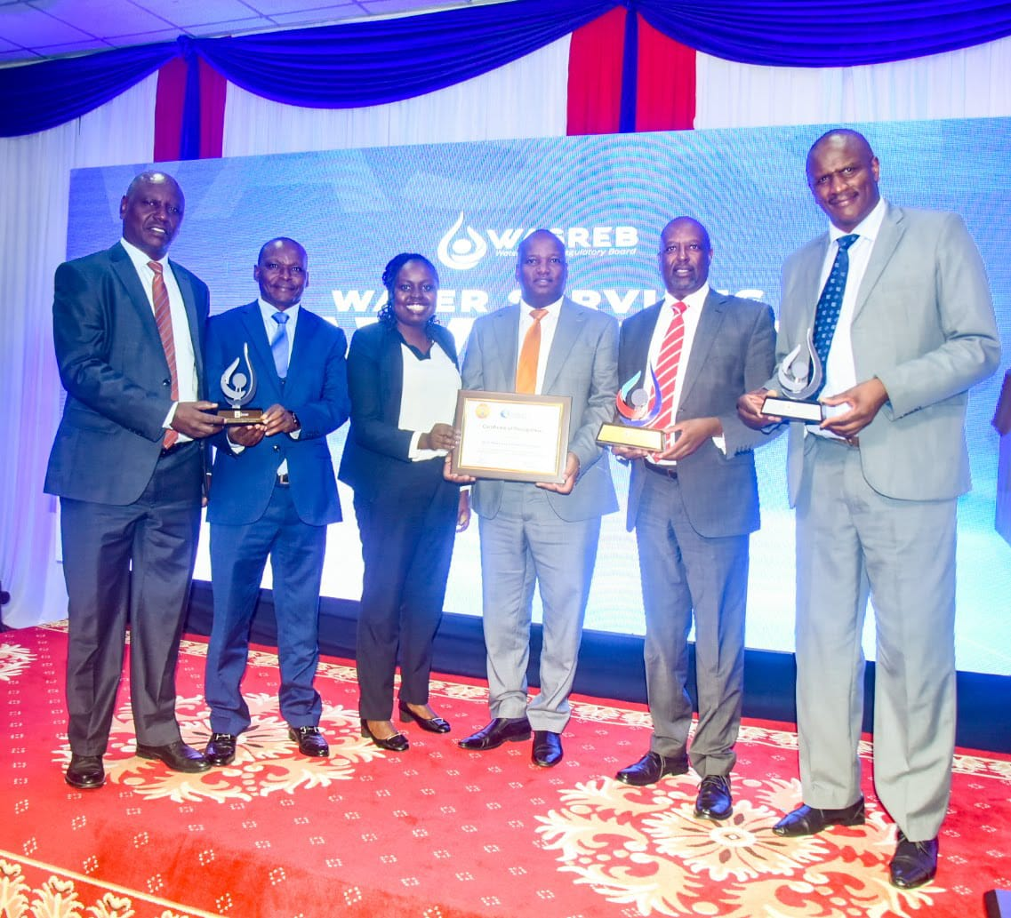
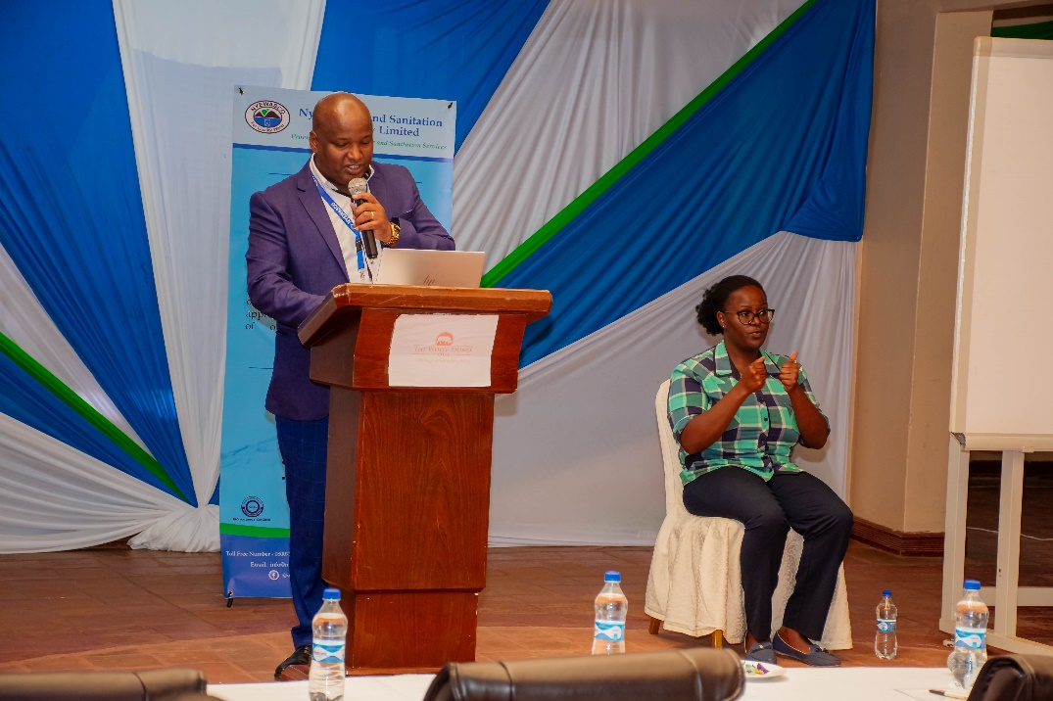
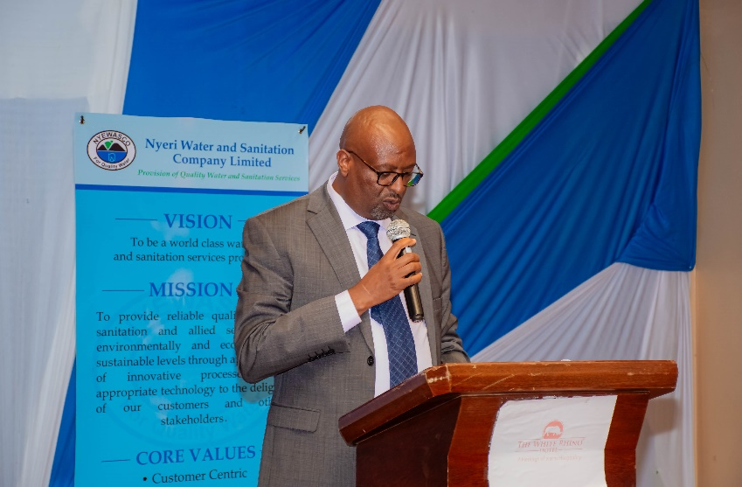
Left: The Managing Director Eng. Peter Kahuthu making his presentation on the Company’s performance during the Conference.
Right: The chairman Board of Directors, CPA Gathogo Mwangi giving his opening remarks during the conference.
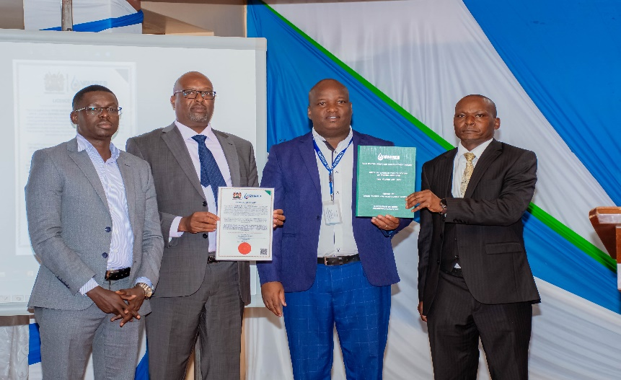
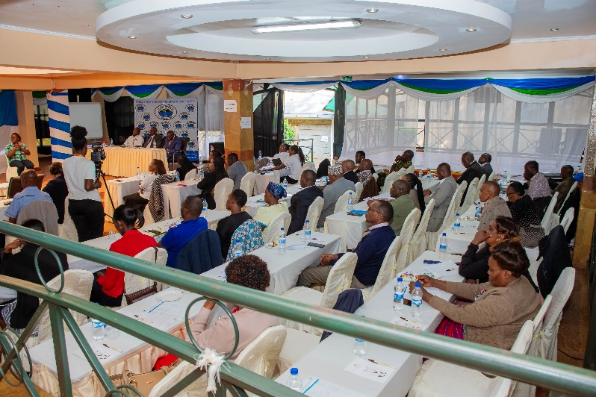
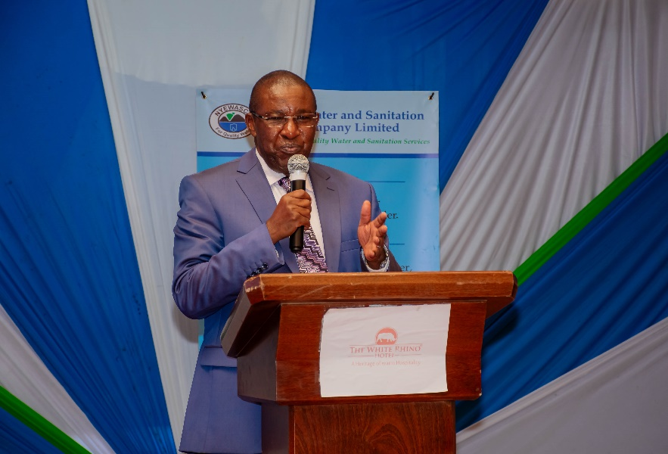
A section of Stakeholders actively participating in a plenary session during the Stakeholder’s meeting at White Rhino Hotel.
Right: The Company Secretary Richard Gikuhi making his presentation on the role of stakeholders in Corporate Governance during the Conference.

WASREB Representative Eng. Kigutu issues copies of the 8 year WASREB License to the MD, Chairman Board of Directors and Director representing the Office of the Governor

LAUNCH OF THE REVIEWED STRATEGIC PLAN FY (2021/22-2026/27)
NYEWASCO launched its mid-term reviewed strategic plan at the White Rhino Hotel on June 3rd. The strategic plan, spanning from FY 2021/22 to 2026/27, was introduced in response to significant changes in the water and sanitation sector's operating environment, including shifts in customer expectations, regulatory guidelines, and stakeholder demands. The plan was developed through internal and external engagements, and aims to provide clear strategic direction for NYEWASCO to enhance service delivery while aligning initiatives with stakeholders' needs.
The strategic plan focuses on seven key result areas—Corporate Governance, Financial Sustainability, Service Delivery, Low-Income Areas (LIA) residents, Human Resource Capacity, Environmental Awareness and Sustainability, and Partnerships & Collaborations the plan seeks to achieve universal access to water and sanitation, as outlined in Sustainable Development Goal No. 6. It also aims to propel the company to international levels in service provision.

Reflecting on the successful implementation of the previous strategic plan, NYEWASCO expresses confidence in the future implementation, emphasizing the importance of sustainable service systems and the collective effort of stakeholders in realizing the company's vision and mission.
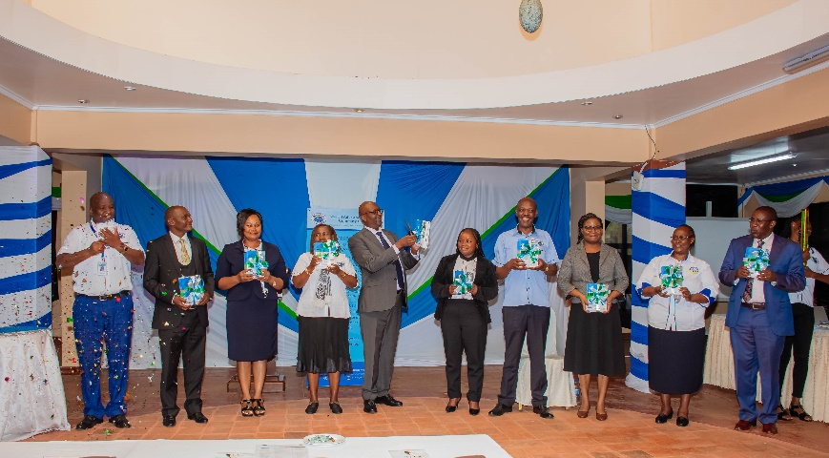
In addition to the strategic plan, the launch event also marked the unveiling of NYEWASCO’s new website, which is part of the company’s commitment to incorporating technology to improve services. The new website is expected to enhance customer service and provide an easier way for stakeholders to engage with the company. The event also celebrated the launch of the NYEWASCO anthem, which symbolizes the company’s dedication and spirit in fulfilling its mandate.
Left: The Board of Directors, The Managing Director and the Company Secretary receive the official strategic plan document during the launch.

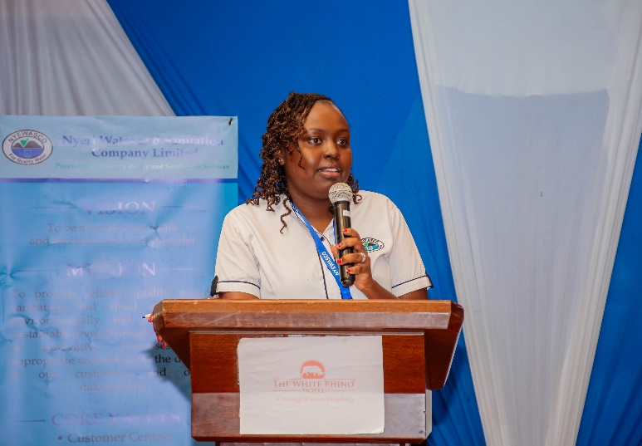
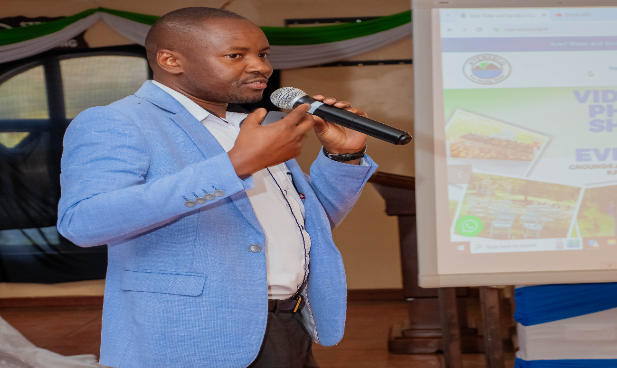
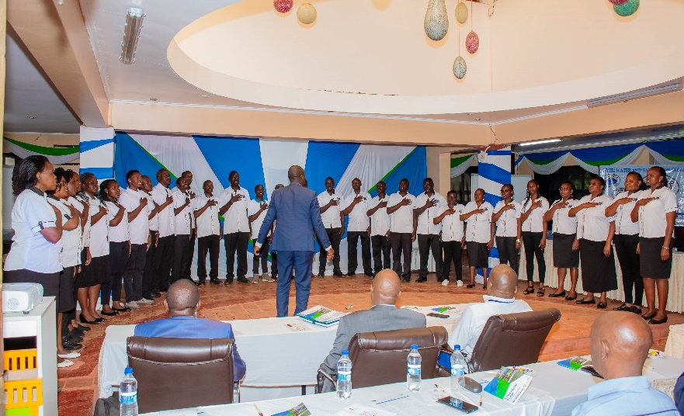
Left: Senior Officer ICT Boniface Mwaniki officially launching the new NYEWASCO Website.
Right: The Chief Manager, Finance and Corporate services CPA Rose Gitahi making a presentation on the reviewed strategic plan
Left: NYEWASCO choir members during the official launch of NYEWASCO anthem.

WORLD ENVIRONMENT DAY
World Environment Day is celebrated annually on June 5. The day is dedicated to promoting environmental awareness, encouraging action and driving change. This year's day has been organised under the theme, 'Land restoration, desertification and drought resilience'.

NYEWASCO celebrated the event at Wambugu Farm, where the Deputy Governor H.E. David Kinaniri, representing Governor H.E. Mutahi Kahiga, highlighted the dependence of Nyeri’s residents on land for sustenance and the threats posed by climate change and biodiversity loss. These challenges are transforming fertile lands into barren areas, jeopardizing agriculture and freshwater resources.
During the recent El Niño rains, Nyeri County experienced significant precipitation, providing a critical opportunity for natural land regeneration and water recharge. These rains were vital for replenishing groundwater levels and supporting local ecosystems, fostering resilience against drought in the region. The increased water availability also enhances agricultural productivity and sustains freshwater resources, aligning with efforts to mitigate desertification and promote sustainable land management.
Nyewasco was represented by the Chief Manager Finance and Corporate Services, CPA Rose Gitahi and other staff members at the event where the company donated 205 tree seedlings to local schools and the community demonstrating Nyewasco’s commitment to conservation and supporting land restoration efforts against desertification and drought.

Additionally, on the same day, the Chief Manager Technical Services Eng. James Ngunjiri led a team from Young Water Professionals in planting over 300 bamboo trees along the river banks at Mweiga old water treatment plant, Kangemi Sewerage treatment plant, and Outspan old water treatment plant. The celebration emphasized the importance of collective efforts to address environmental challenges, with Nyewasco’s contributions showcasing the significant impact of community involvement in land restoration and resilience building.

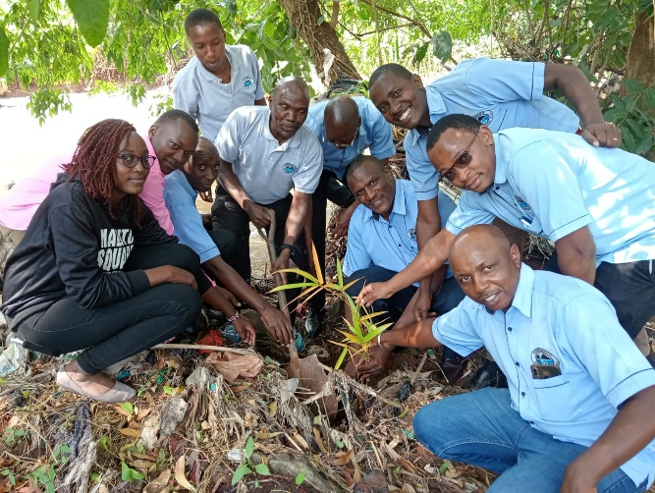


Top Left: The Deputy Governor H.E. David Kinaniri together with the Chief Manager Finance and Corporate Services, CPA Rose Gitahi donating a tree to Narumoru Township Primary school.
Top Right: Nyewasco staff members donate tree seedlings to Gatugi girls secondary school on Environment day.
Bottom Left: The Chief Manager Technical Services Eng. James Ngunjiri leads a team from Young water professionals in planting bamboo trees.

RELEASE OF IMPACT REPORT NO. 16 BY WASREB
The 16th edition of the Impact Report, titled "IMPACT 16," was launched on June 20th, 2024 by the Water Services Regulatory Board (WASREB) of Kenya. This annual report assesses various aspects of Kenya's water services sector, encompassing areas such as water coverage, drinking water quality, non-revenue water, metering ratio, sanitation coverage, dormant connections, and hours of supply.
Nyeri Water and Sanitation Company (NYEWASCO) garnered multiple accolades which include:
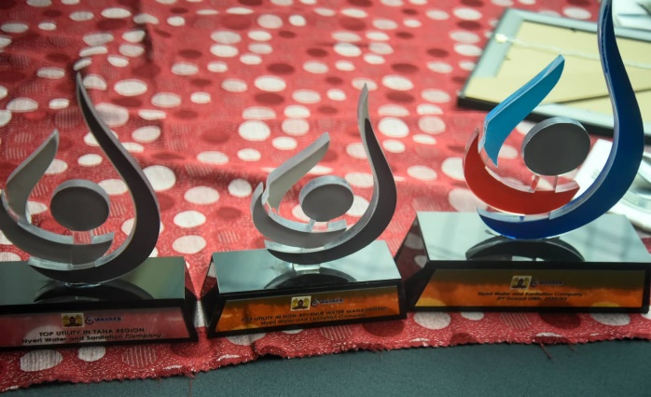
- Ranked as the Top Utility in NRW (Non-Revenue Water) Management.
- Recognized as the Top Utility in the Tana Region
- Secured the 2nd position overall
- Joint-top Utility in Pro-Poor Services.
- Awarded a Certificate of Recognition for the best performance among water and sanitation utilities in the ESAWAS regional benchmarking for the 2021/22 period.
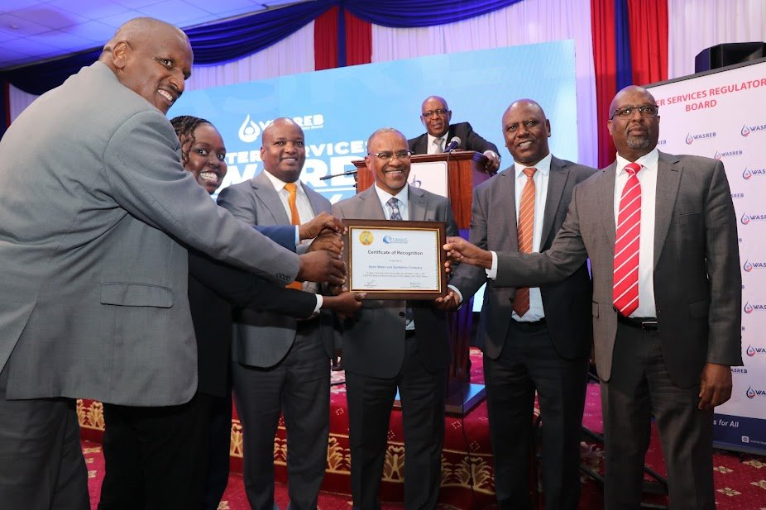
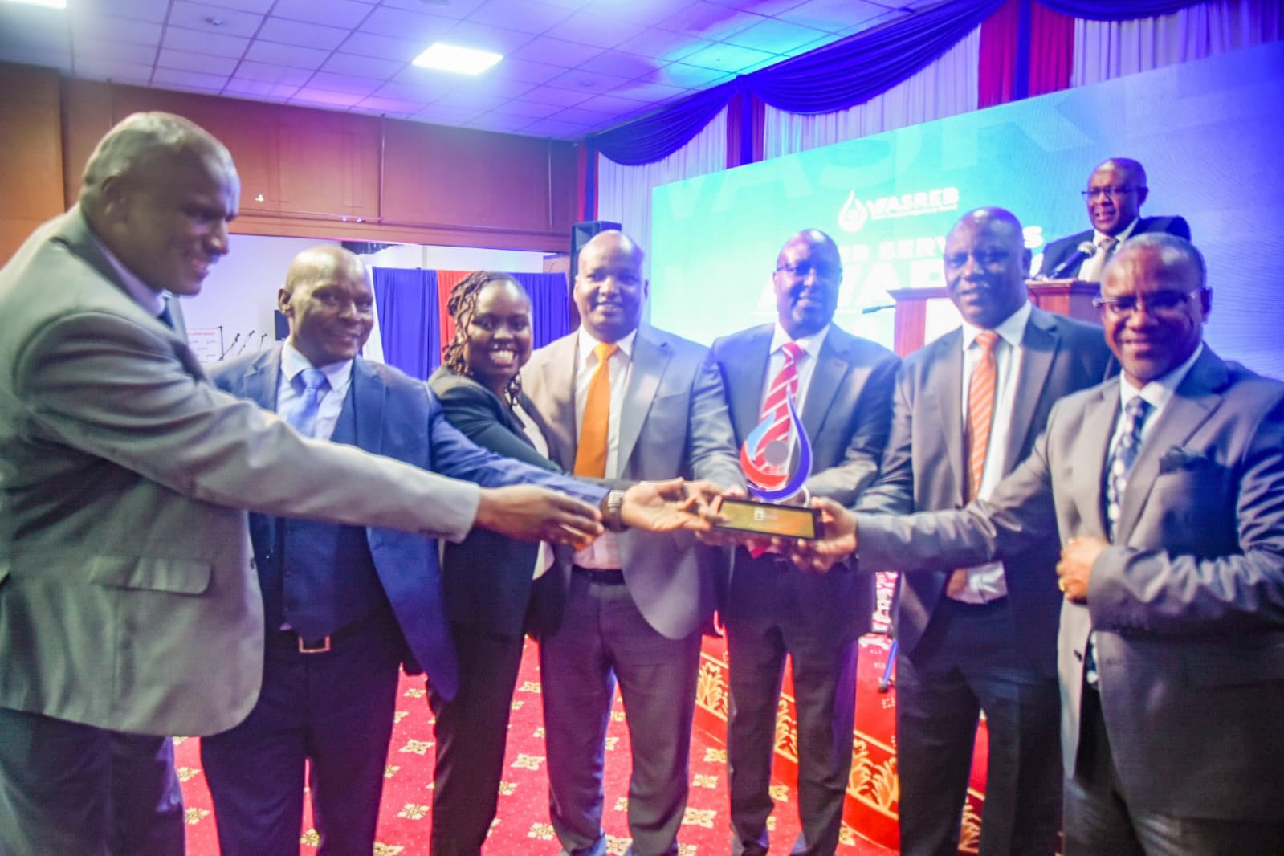
This success underscores the Company's unwavering commitment to excellence and its dedication to delivering superior products and services within the water sector. We take immense pride in these achievements, which reflect our ongoing efforts to set benchmarks in water management, service provision, and equitable access to water and sanitation. NYEWASCO remains steadfast in its mission to make a substantial and positive impact on the industry, ensuring sustainable water access and quality for all stakeholders.

Top: Nyeri Water, Irrigation, Environment and Climate Change CECM, The Chairman, NYEWASCO B.O.D, The Managing Director, Chief Manager Technical Services and Chief Manager Finance and Corporate Services receive a trophy and the ESAWAS certificate of recognition from Hon. Zachariah Njeru, CS, Water, Sanitation and Irrigation.

Left: The team poses for a photo with trophies received during the event.

SPECIAL GENERAL CORPORATE MEETING

Impact 16 Updates
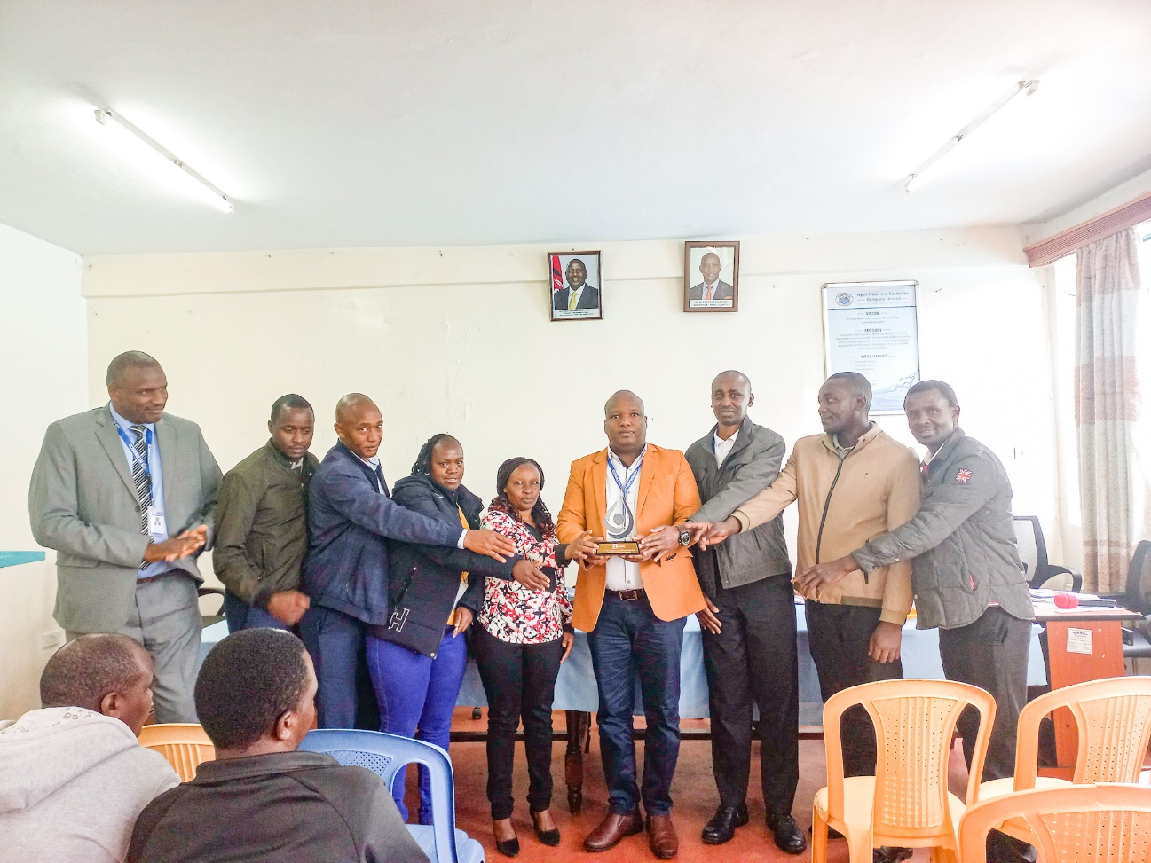
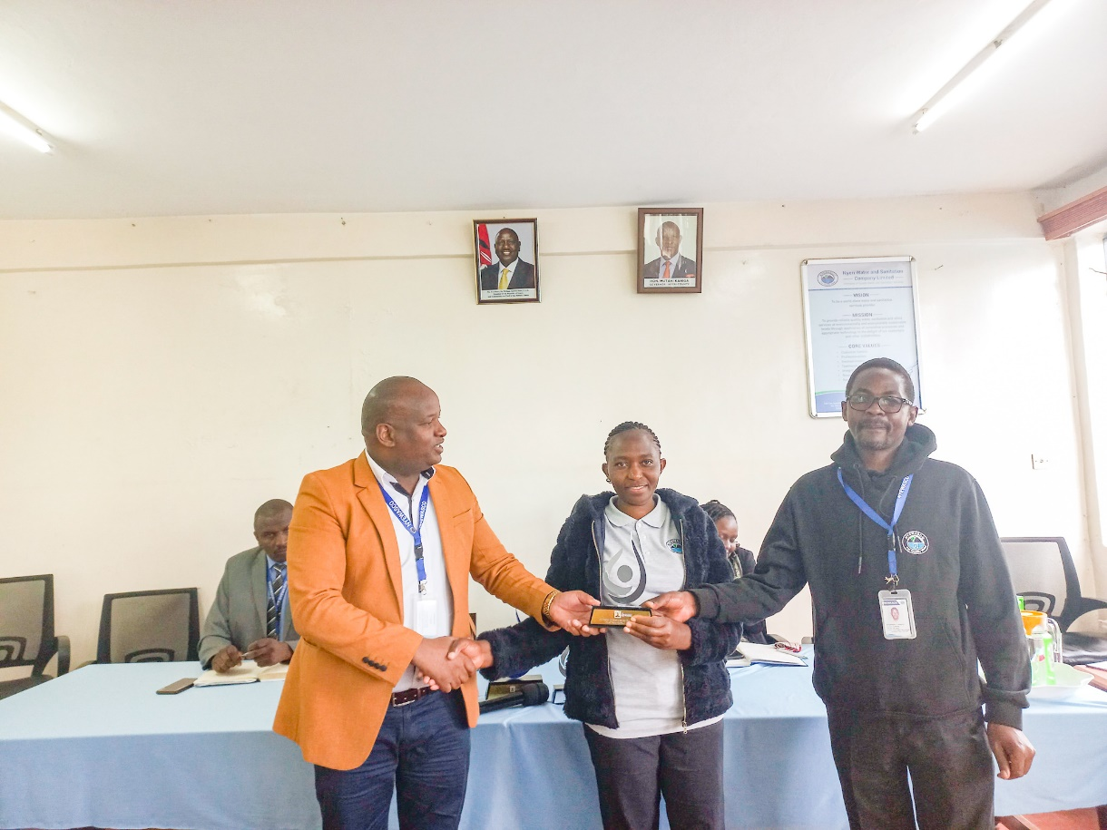
The company convened a special general meeting on June 28, 2024, focused on the release of the WASREB Impact 16 report. During the meeting, the Managing Director addressed the company's performance as highlighted in the recent report. Notably, NYEWASCO emerged position 2 overall with 165 points, trailing Nakuru Water and Sanitation Company which garnered 166 points. Nanyuki water emerged position 3 with 162 points. This position represented a drop in points from previous years, influenced by a decrease in water coverage, rated at 82% compared to 98% the previous year as a result of not capturing Multi dwelling units data which has now been addressed.
Left: The MD, Eng. Peter Kahuthu issuing the Impact 16 Report updates to staff members.
Right: The MD handing over the Top Utility in NRW management trophy to staff members from NRW, Distribution and Investigations & security.
Left: The MD handing over the Top Utility in Pro-poor services trophy to staff members from the Pro-poor Services Division.
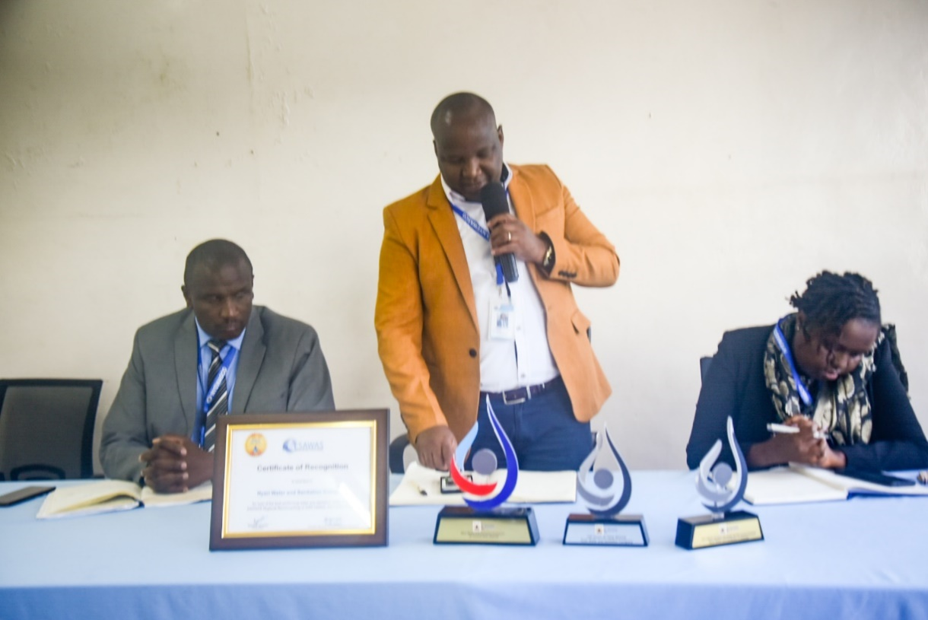
Despite this setback, the Managing Director acknowledged the achievements of various staff members by presenting trophies to staff from different divisions in recognition of their contributions. Emphasizing a steadfast commitment to excellence, the MD urged all employees to maintain their dedication, underscoring the collective effort required to propel the company to even greater success in the future.

3RD COHORT INTERNS GRADUATION
On the 28th of June, the company celebrated the graduation of its third cohort interns (2023-2024), who had undergone intensive training in various departments. The luncheon was graced by speeches from the senior management team, led by the Managing Director, Eng. Peter G. Kahuthu.

For the interns, transitioning from this internship into the broader professional world presents both opportunities and challenges. The management's advice to them included embracing continuous learning, fostering meaningful relationships, and seeking and acting on feedback for personal growth. Setting clear goals, maintaining a positive attitude, and embodying integrity and professionalism were emphasized as crucial elements for success. The management encouraged the interns to embrace change and innovation, take initiative in their careers, and maintain a healthy work-life balance to sustain well-being and productivity.

As a token of recognition for their hard work and dedication, each graduate was presented with a recommendation letter, highlighting their achievements and potential. Armed with this letters and the knowledge they have acquired during their internship period, the graduates are prepared to take on the world and make their mark.
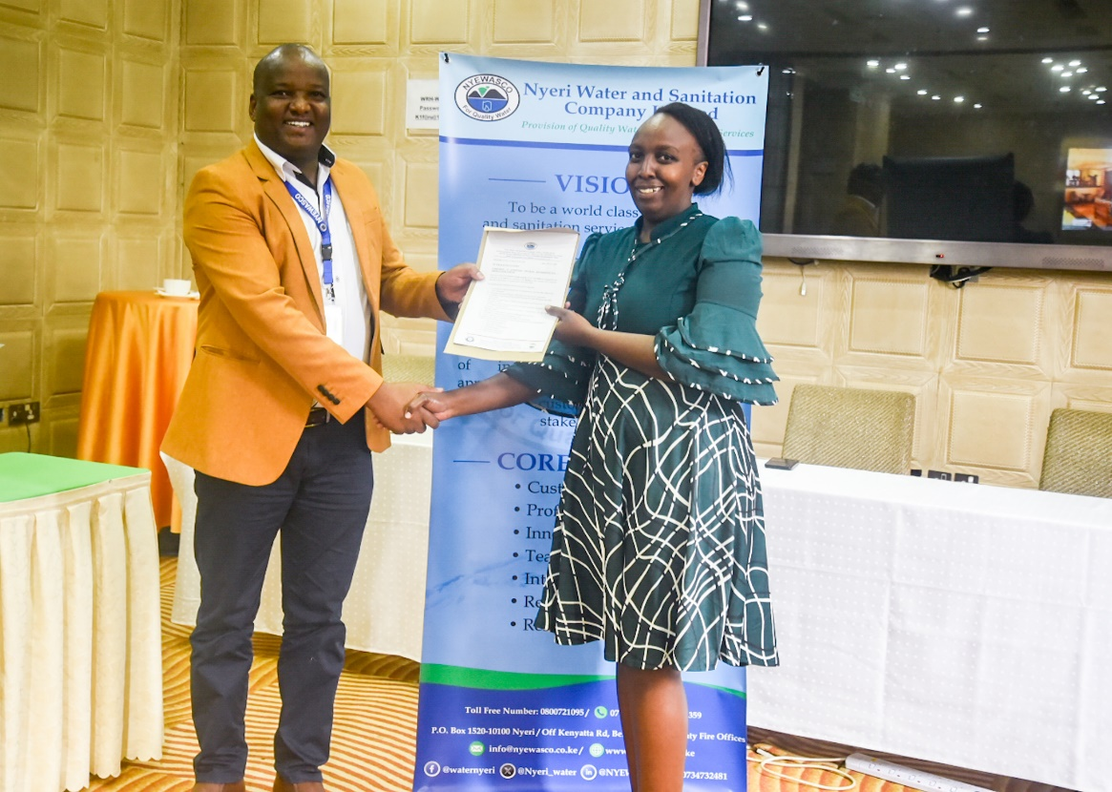
Congratulation to the third cohort interns! Best of luck in your future endeavours.

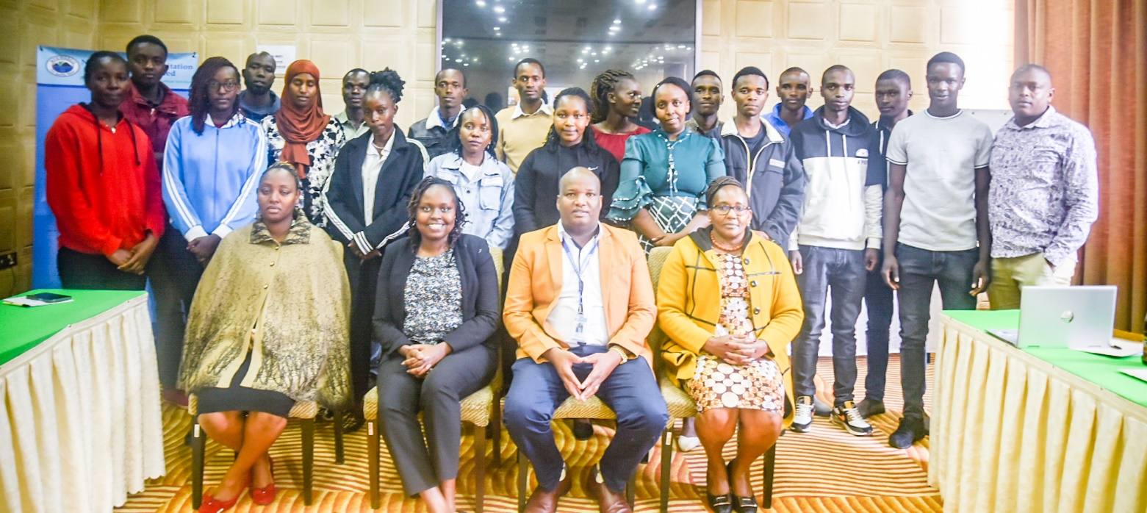
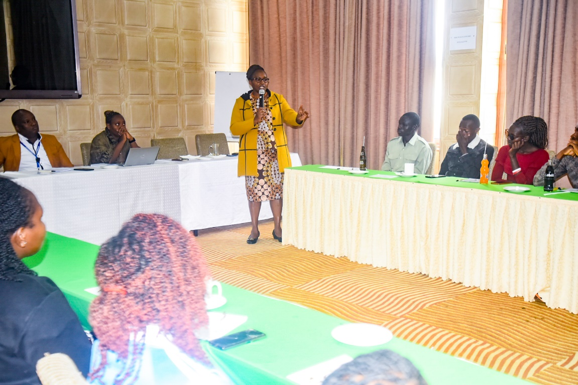
Left: The MD handing over a letter of recommendation to one of the graduating interns.
Right: The Senior Officer HR & Admin CHRP Joyce Munira addressing the interns during the 3rd cohort graduation.
Left: The third cohort of interns pose for a photo together with the Management.
UPSCALING BASIC SANITATION FOR THE URBAN POOR (UBSUP) PHASE II MAJENGO, WITEMERE, RURINGU HOUSEHOLD SANITATION PROJECT

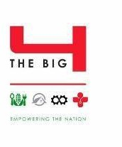

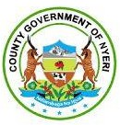
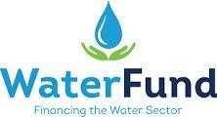

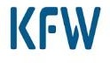
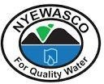
Left: The BOD Chair and the MD receive a souvenir from the GTN Team

UBSUP is a country-wide up-scaling intervention aimed at providing access to basic household sanitation in urban low income areas of Kenya. It is anchored at the Water Sector Trust Fund (WSTF) with technical support from GIZ and funding from the German Government through the German Development Bank (KfW). The programme is implemented by licensed Water Services Providers (WSP/utilities) and covers the entire sanitation chain. UBSUP involves the scaling up of the following activities: promotion of improved toilets at household level, involvement of the private sector to provide emptying and transport services, implementation of Decentralized Treatment Facilities (DTF) to offer treatment and safe disposal of the fecal sludge.
During the quarter, Water Sector Trust Fund (WSTF) officers paid us a visit to inspect the progress of the ongoing Majengo- Witemere UBSUP II project. During their visit, the team visited Witemere, Majengo and Ruringu areas, witnessing firsthand the development of modern toilet facilities. This project signifies a significant step towards ensuring improved sanitation and hygiene standards for the community.
By the end of the quarter, 262 toilets had been completed and subsidies paid to the beneficiaries.

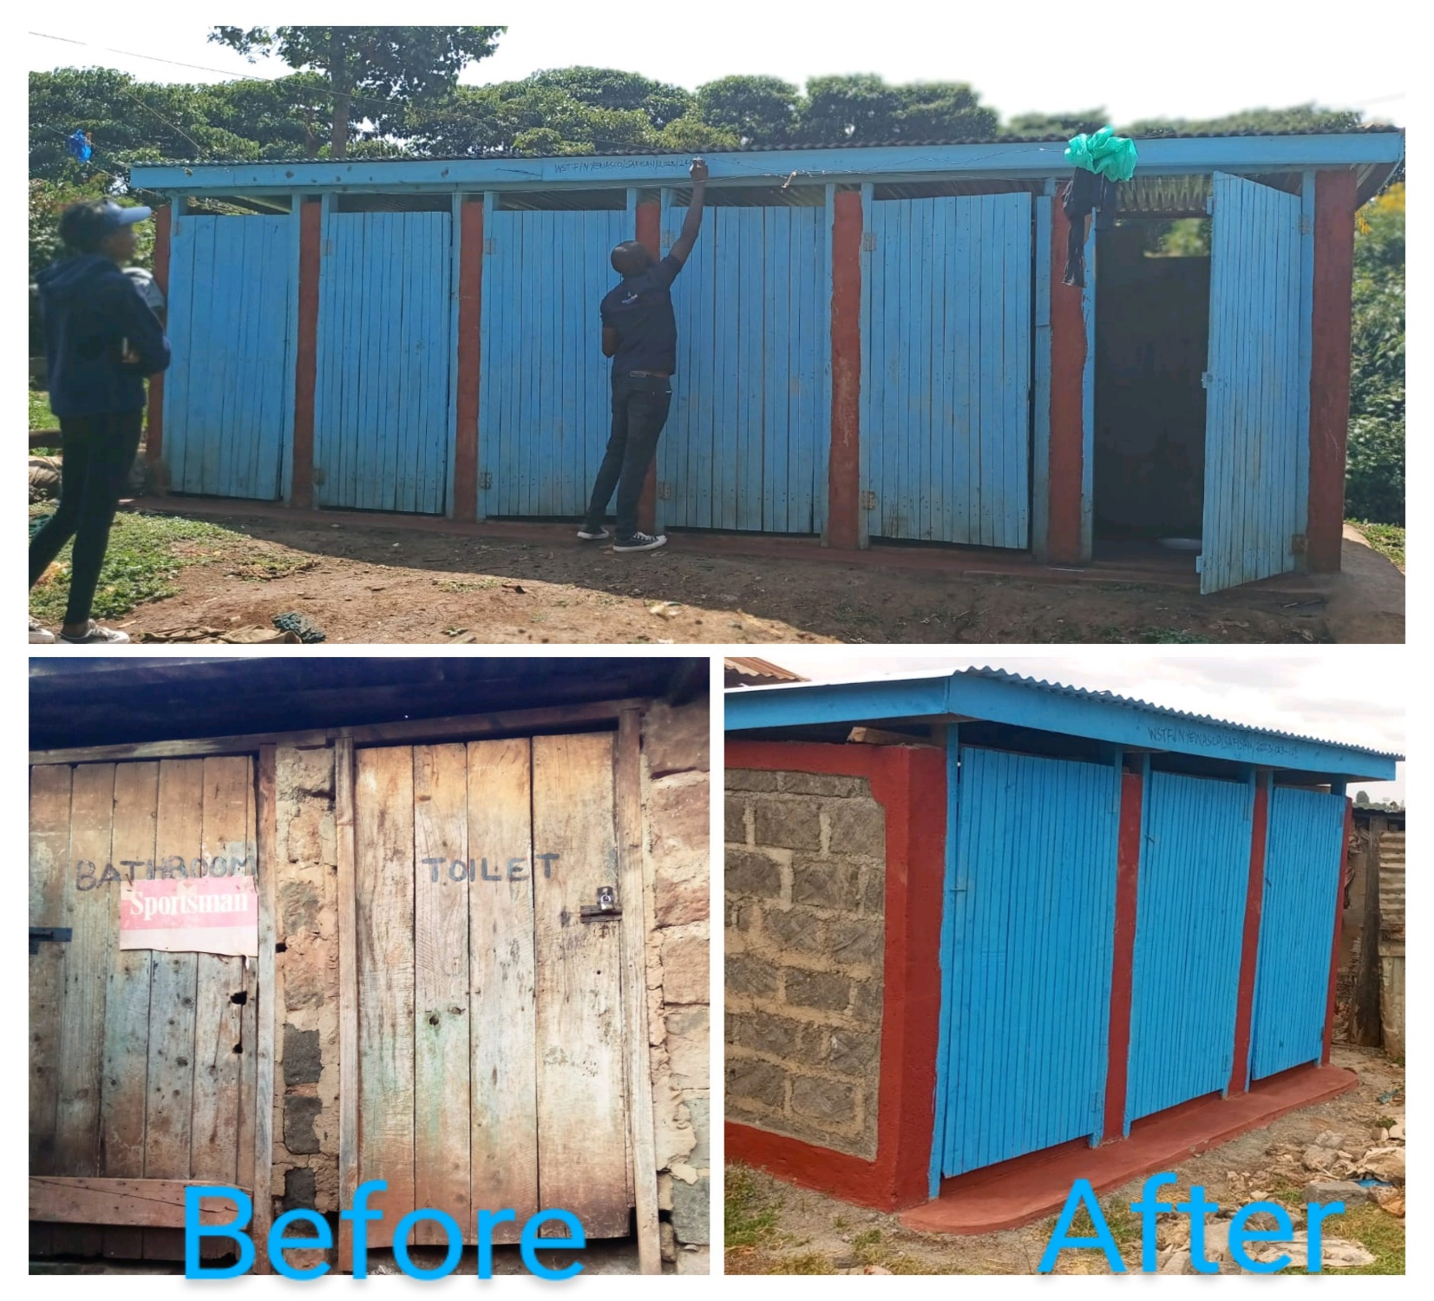

CORPORATE SOCIAL RESPONSIBILITY INITIATIVES
‘IN THE HEART OF CSR’
Corporate social responsibility (CSR) refers to strategies that companies put into action as part of corporate governance that are designed to ensure the company’s operations are ethical and beneficial for society. The Company has been a beacon of Corporate Social Responsibility (CSR) in its operations. The company’s CSR initiatives are deeply rooted in its core values. During the quarter the Company took part in several CSR initiatives.


Right: Nyewasco staff members donating tree seedlings to Gatugi girls secondary school on Environment day.
.



Left: Chief Manager Finance and Corporate Services CPA Rose Gitahi at the Kenya Youth Empowerment Forum where Nyewasco were sponsors of the event.

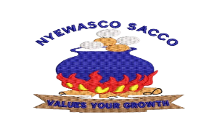
NYEWASCO SACCO UPDATES

PRODUCTS

Product | Permanent Staff | Contract | Casuals | Remarks
Normal Loan | 5 times deposit | 4 times | 1.5 times Deposit
 | Up to 36 Months repayment period, interest is 12%PA | Up to 36 Months repayment period,  interest is 12%PA | Maximum repayment period 18  Months @ 12%PA
 | Above 36 Months to 60 Months repayment period, interest is 14%PA | Above 36 Months to 48 Months repayment period, interest is  14%PA
School Fees | 12 Months repayment period @ 12% interest PA | 12 Months repayment period @ 12% interest  PA | 12 Months repayment period @  12% interest PA
Emergency | 12 Months repayment period @ 12% interest PA | 12 Months repayment  period @ 12% interest PA | 12 Months  repayment period @ 12% interest PA
Soft Loan | 6 Months repayment period @ 15% interest PA | 6 Months repayment period @ 15% interest  PA | 6 Months repayment  period @ 15%  interest PA
Compassionate Loan | 24 Months repayment period @ 18% interest PA | 24 Months repayment  period @ 18% interest PA | 24 Months  repayment period @ 18% interest PA
Jijenge Loan | 12 Months repayment period @ 12% interest PA | 12 Months repayment  period @ 12% interest PA | 12 Months  repayment period @ 12% interest PA
Dividend Loan | A third of net interest on shares and deposits payable within 4 months at the rate of 4% per Month | A third of net interest on shares and deposits payable within 4 months at the rate of 4% per Month | A third of net interest on shares and deposits payable within 4 months at the rate of 4% per  Month | Applicable From January of every year
Guarantor ship | At least 5 guarantors required | At least 5 guarantors required with two being  Permanent | At least 7 guarantors required with two  being permanent

From NYEWASCO SACCO Desk

USHIRIKA DAY

Ushirika day is an annual held on the first Saturday of July at County level to increase awareness about cooperatives and promote their principles and values. This year celebrations will be held on 6th July 2024 at the Governor’s Office ground. Last year, Nyewasco Sacco managed to scoop two awards.

INSURANCE COVER

The SACCO management wishes to inform cooperators that Loan insurance cover is currently being provided by ICEA Lion.

NYEWASCO WELFARE UPDATES

The welfare group's main objective is to provide financial support to members during times of need. In that line, members should acquaint themselves with the following articles as summarized;
- Membership is open to all NYEWASCO employees. Each Registered member contributes Kshs 500.00 per month which is deducted at the point of payroll processing. To qualify for benefits from the group:
To qualify for benefits from the group:
- A new employee benefits after the first-month deduction.
- An existing employee benefits after 6 months of Contribution.

The following are the summarized benefits as tabled below
WELFARE BENEFICIARY TABLE
Details | Medical | Death | Maternity/  Paternity | Wedding | Exit of Service | Beneficiary
Member | 15,000.00 | 25,000.00 | 10,000.00 | 15,000.00 | 25,000/15,000 | Member/next of kin
Spouse | 10,000.00 | 20,000.00 |  |  |  | Member
Child(ren) | 10,000.00 | 20,000.00 |  |  |  | Member
Biological Parent |  | 15,000.00 |  |  |  | Member
Biological Brother/Sister |  | Members contribute Ksh.50 through payroll |  |  |  | Member
Source: Nyewasco Welfare Constitution
Note: Exit of service might be through retirement or withdrawal from service

During the Quarter under review 2024, the following cases were addressed as tabulated below:
WELFARE BENEFICIARY TABLE
Details | Medical | Maternity/Paternity | Beneficiary
Member | 105,000.00 | 50,000.00 | Member/next of kin
Spouse | 40,000.00 |  | Member
Child(ren) | 70,000.00 |  | Member
Biological Parent |  |  | Member
Biological Brother/Sister |  |  | Member

Congratulations for New Born Baby blessings throughout the Quarter!
We appreciate the members for the support accorded.
The welfare office will endeavor to provide support to the members.
Welfare Desk.
WASCO GAMES
Preparations for the 13th edition of the WASCO Games to be hosted by Murang’a Water and Sanitation Company are ongoing, and teams are urged to put in the hard work as July 8th to July 12th has been reserved as the week for final teams formation.
The tentative dates for the games, according to the calendar, are Monday 12th to Friday 16th August, 2024.We shall keep you fully updated as we prepare to mount a serious challenge for position one in Murang'a.
We would also like acknowledge the invaluable efforts of the sports committee members who are diligently overseeing the planning and execution of these games.
Keziah Nyambura – Chairperson
Mercy Gathogo - Member
Rose Muchiri - Member
Patrick Wambugu – Member
Peter Muchoki - Member

Paul Michuki – Team Manager
Jane Kago – Assistant Team Manager
Joyce Munira – Member

Paul Michuki Jane Kago
Team manager Asst. Team Manager

MAY & JUNE BIRTHDAY CELEBRANTS

May the journey ahead be enriched with an abundance of joy that fills your hearts with happiness. Here's to beginning another remarkable orbit around the sun cheers to the adventures that lie ahead!



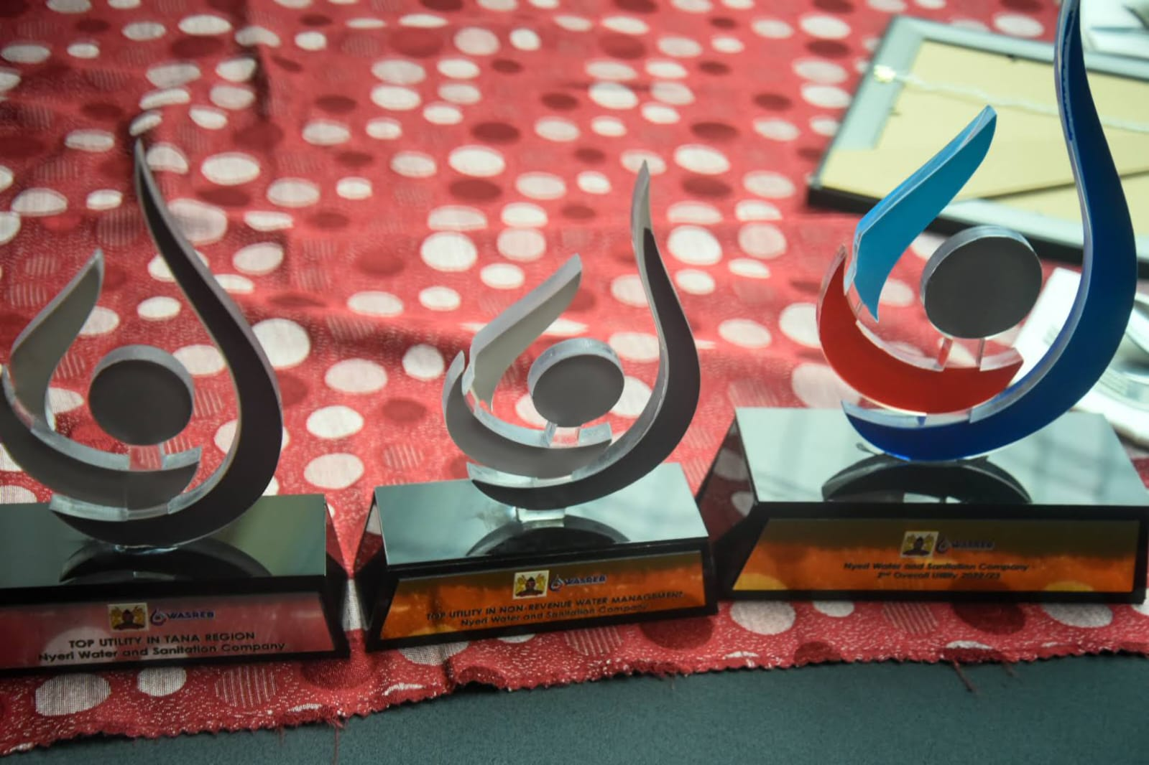

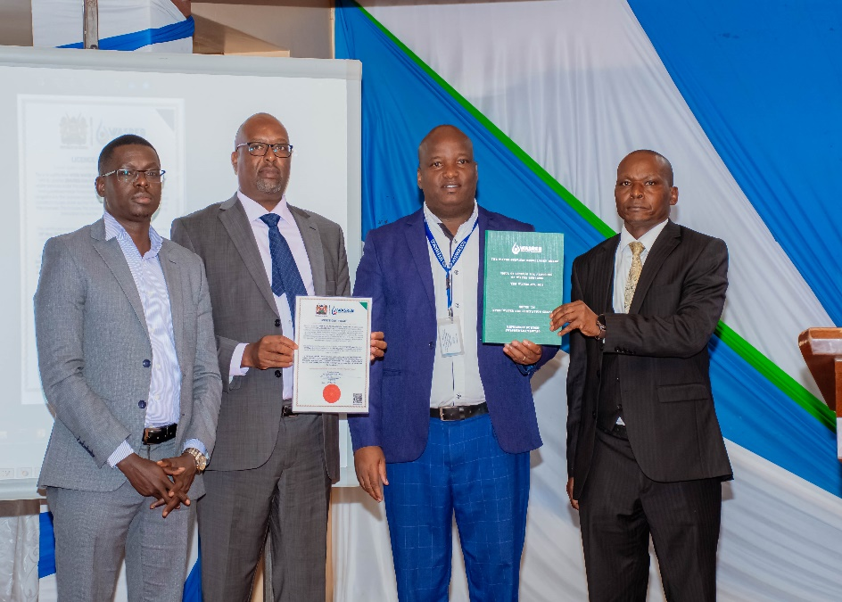
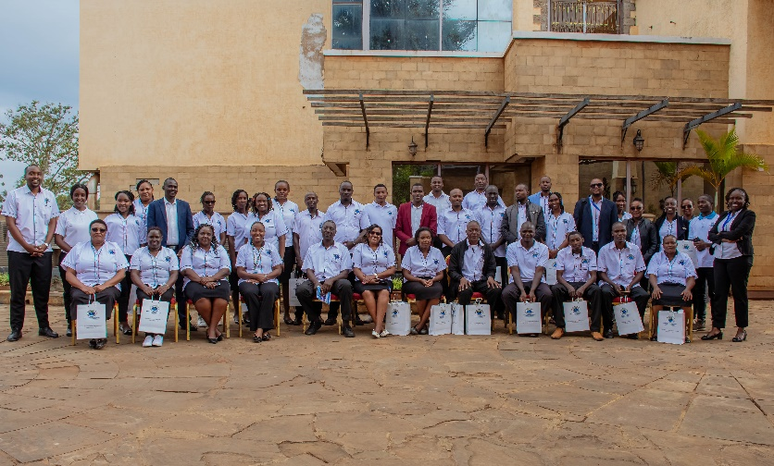

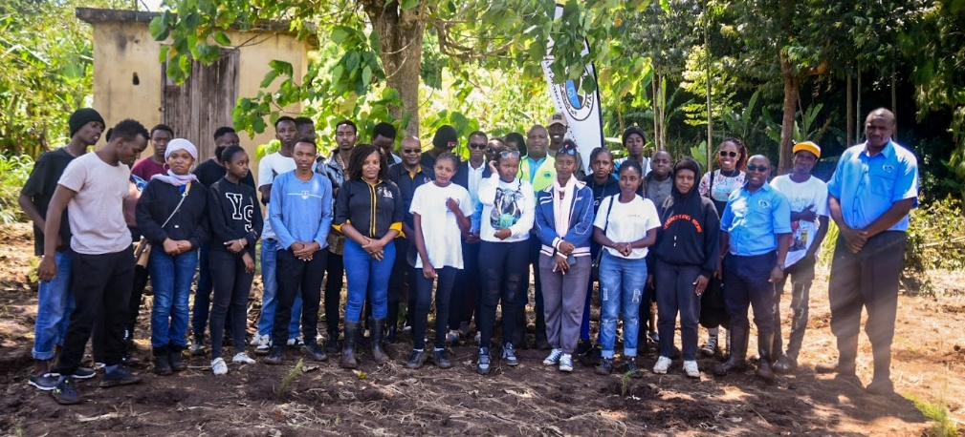
NYEWASCO IN PICTURES
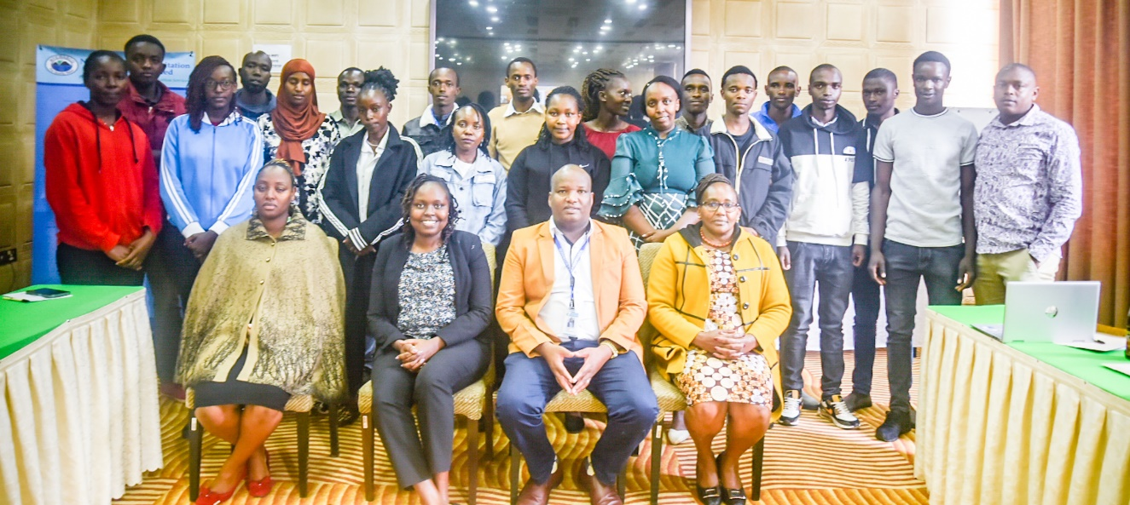

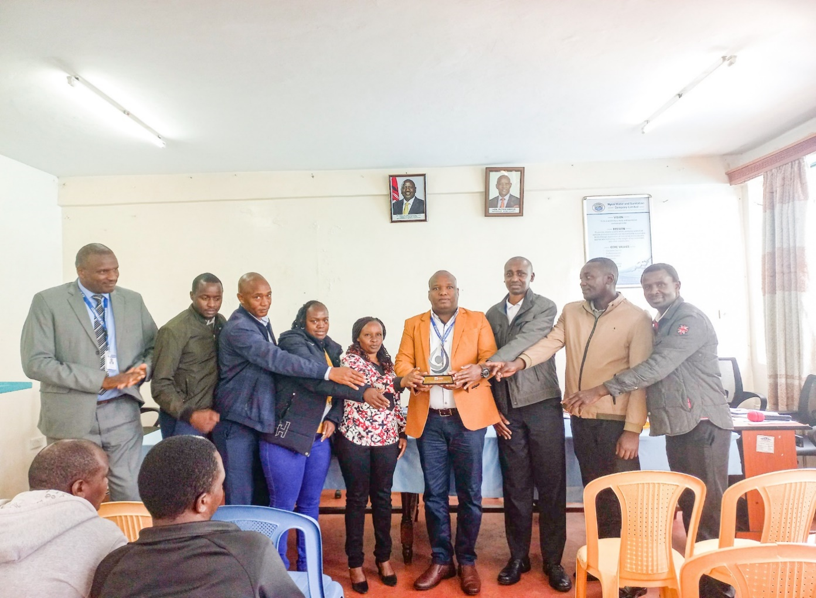

Following the heavy rains experienced in our service provision area in the month of April and part of May 2024, both water and sanitation infrastructure have massively been affected interfering with the normal service delivery.
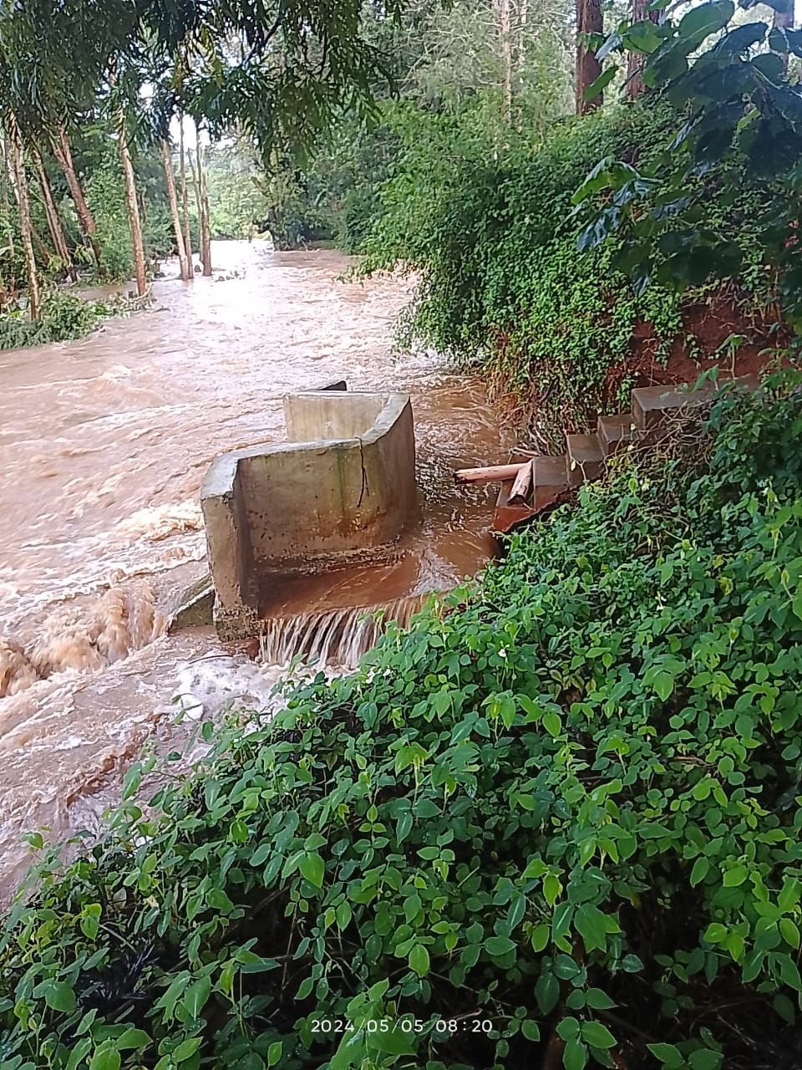 | 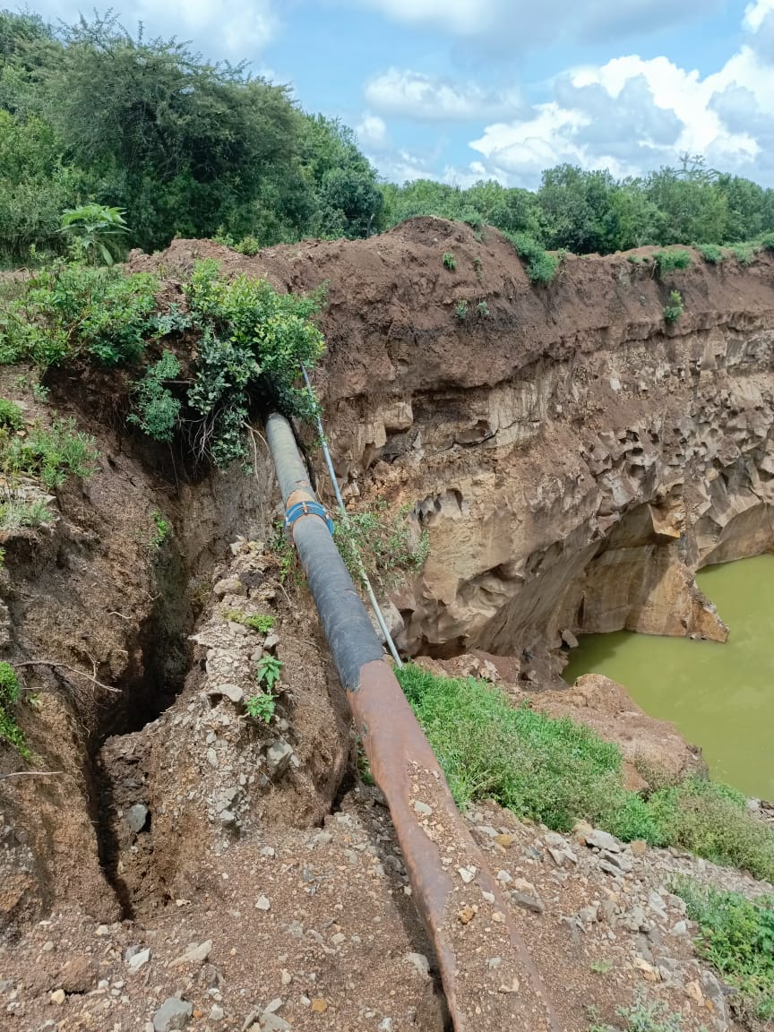
Damage at Kangemi Sewer Effluent Outlet | Collapsing Gatei DN 200mm bituminous coated steel Sewer Raising Main Pipe

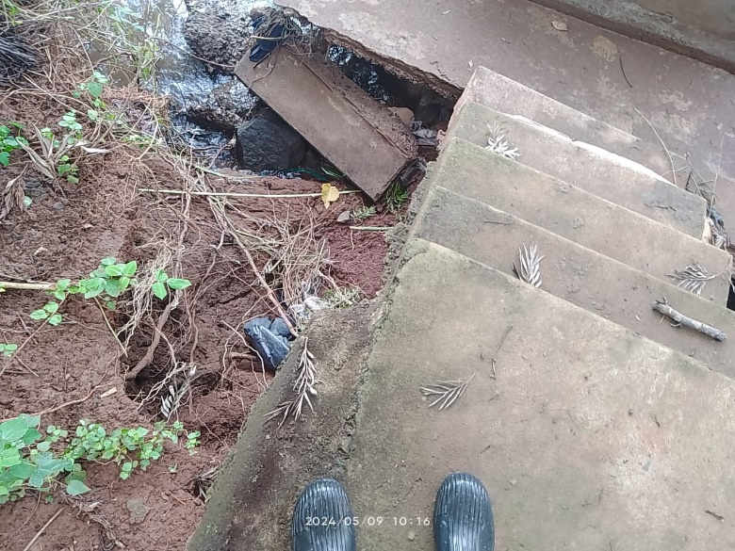 | 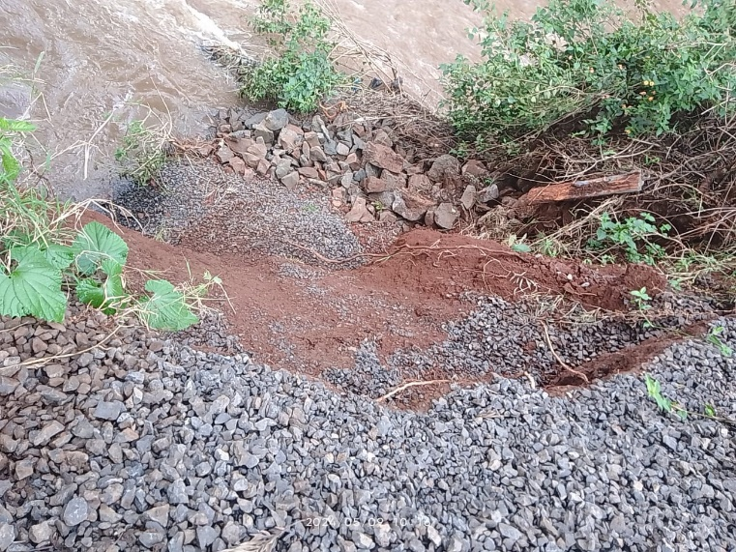
Damage at Kangemi Sewer Effluent Outlet | Flood damage along Outlet Embarkment

TUMULIKE MWIZI PAMOJA CAMPAIGN
Nyeri Water and Sanitation Company has launched a Tumulike Mwizi Pamoja Campaign aimed at reducing commercial losses occasioned by water theft through illegal water and sewer connections and discharge of waste water at undesignated discharge points. The campaign is aimed at educating customers and the general public of the penalties that accrue from the vice and encouraging them to report such cases to the Company or the police. The campaign which is being led by the Communications & Public Relations Office in conjunction with the Security and Investigations Office, Pro-Poor Office, Customer Care Office, Customer Relations Office as well as the Business Development and Marketing Office covers the whole of NYEWASCO’s service area with a concentration in the low- income areas where this vice is commonly found.
Did you know that water theft through illegal connections or meter by-passes, self- reconnection after cut off for non- payment is a criminal offence punishable by law? The following penalties applies:
ILLEGAL CONNECTION: Commercial, Industry, Construction fraud- Sh. 100,000.00 plus estimated consumption during the period of illegality.
ILLEGAL WATER CONNECTION: Domestic- Sh.30,000.00
SELF CONNECTION after cut off for non -payment Sh.5,000.00 and billing backdated from date of cutoff. These penalties have been set by Water Services Regulatory Board (The Kenya Gazette No. 2188) to deter water theft and failure to pay may lead to a jail term.
Currently, one person who was involved in water theft has been arrested by our security & investigation department whose mandate is to weed out the vice. He was arrested and taken to Central Police Station where he was booked and is out on cash bail. He is required to pay for the penalty and billing backdated from the date of cut off. The total sum has escalated way above what he owed before the illegal connection and failure to pay will lead to criminal charges being brought against him. It is not worth the trouble. Get a legitimate water connection to avoid these penalties. Our team is on the ground verifying all water and sewer connections.
We urge our customers to report to us any case of water theft, illegal water and sewer connections, illegal discharge of waste water in un-designated points, meter vandalism and theft to the nearest police station or to us through the following communication channels:
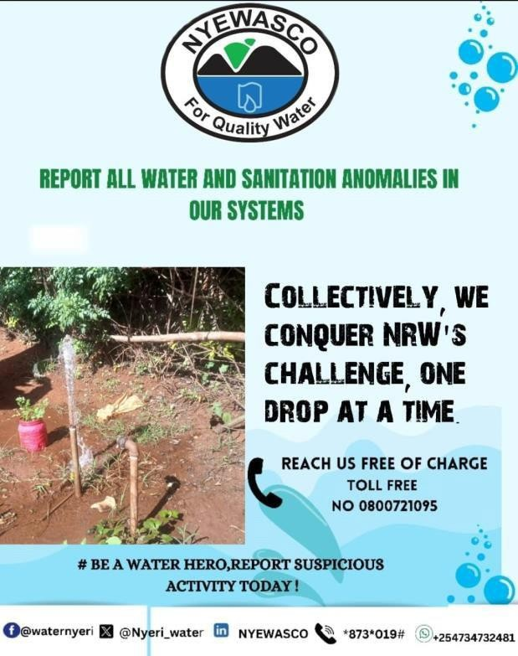
Facebook: @waternyeri
X: @Nyeri_water
Whatsapp: 0734 732 481
LinkedIn: @NYEWASCO
Toll free phone number: 0800721095
Email: info@nyewasco.co.ke
Phone number: 0734 732 481/ 0714 430 000.
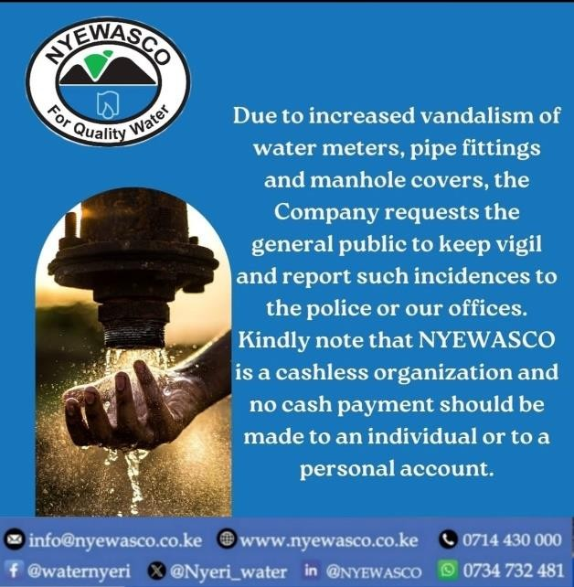
Let's stop mwizi together. Help us serve you better.

OUR SERVICES



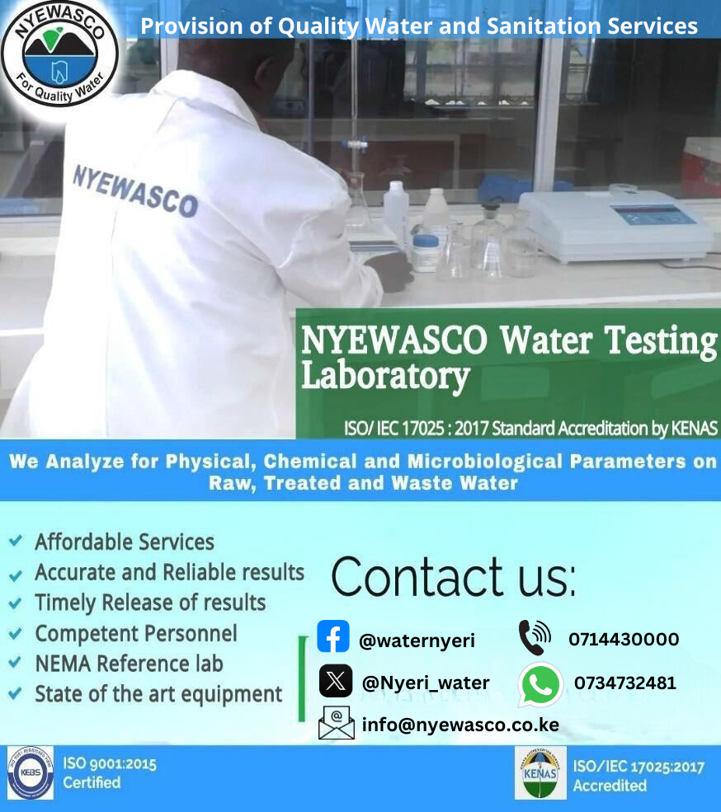
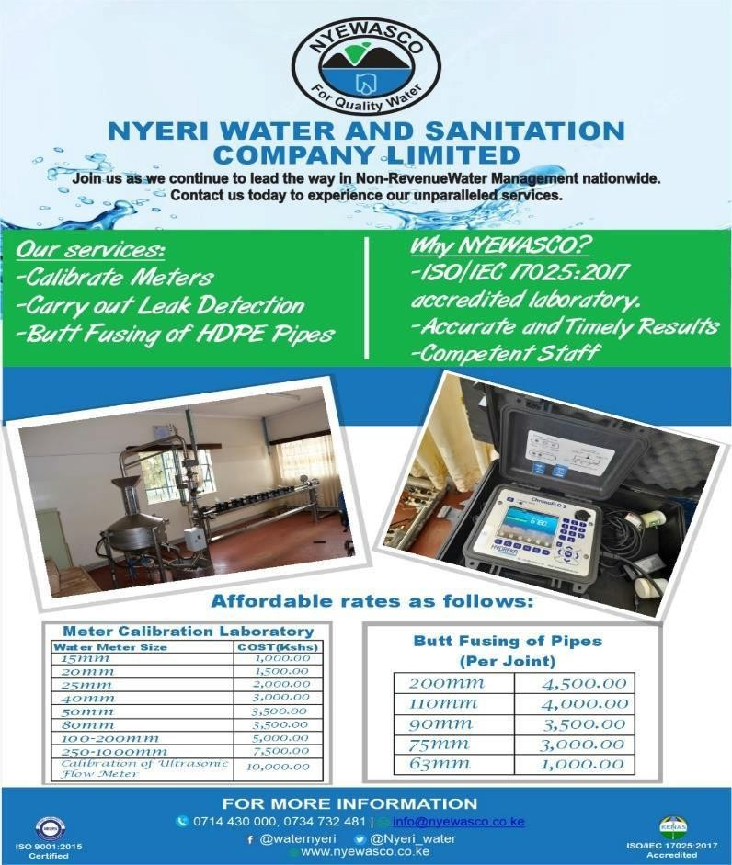

NYEWASCO ANTHEM
Oh God of all natural resources,
Bless and guide NYEWASCO,
In excellent provision of water, sanitation to all our clients
And excellent provision of water, sanitation at sustainable levels.

Delight, delight in our clients
Stakeholders delight (delight),
We pride in technocrats, innovation in service to all our clients,
A world class provider of water, sanitation we be.

We're guided by our professionalism,
Our teamwork, Integrity, positivity
Core values guides us, we prosper together, together we stand
Our values unite us, we flourish together forever we serve.

